*Somerset Model of Intermediate Care*

*Standard Operating Procedure*

|  |  |
| --- | --- |
| **Policy Title** | Standard Operating Procedure |
| **Author/Contact** | Contact: Kate Smith  Authors: Kate Smith, Iona Brimson and contributions from service managers |
| **Version** | V0015 |
| **Status** | V0014 signed off at Intermediate Care Board October 2021  Revision – in progress |
| **Publication Date** | Last publication October 2021 |
| **Review Date** | Due October 2022 |
| **Approved by** | Intermediate Care Operational & Governance Group |
| **Ratified by** | Intermediate Care Board |
| Distribution: Somerset system partners  Please note that the published Intranet version of this document is the only version that is maintained.  Any printed copies must therefore be viewed as “uncontrolled” and as such, may not necessarily contain the latest updates and amendments. | |

# Contents

Contents 2

List of Diagrams 3

Introduction 4

1. Definition of Intermediate Care 5

2. The Somerset Hub for Coordinating Care 8

3. Referral Sources into Intermediate Care 10

3.1 Acute Supported Discharge: Referrals into Intermediate Care 10

3.2 Diversion: Referrals into Intermediate Care 13

4. Intermediate Care Pathways 15

4.1. Neighbourhood Teams and Rapid Response (Hub Option 1) 15

4.2. Home First Pathway 1 - Discharge to Assess Home (Hub Option 2) 18

4.3 COVID-19 - Supporting Discharges into D2A Home First Pathway 1 ………………………………………………….. 23

4.4. Bedded Care (Hub Option 3) 28

4.5. End of Life Care (Hub Option 4) 38

6. Voluntary and Community Sector – Option 5 41

6.1 Operating arrangements for the Community Single Point of Contact (SPOC) ………………………………………. 41

6.2 Referral Process to VCSE ……………………………………………………………………………………………………………………… 43

7. Adult Social Care Support across Intermediate Care …………………………………………………………………………………. 43

Health Interface Service 44

ASC Locality teams 44

8. Governance and Reporting 47

8.1 System reporting and monitoring 47

8.2 Governance 47

8.3 Escalation Policies 47

9. Appendices 48

9.1. Intermediate Care Model- Formal Complaints Pathway 48

9.2. Covid-19 related Policy 49

9.3. Guidance for the Use of Interim Beds 49

# List of Diagrams

|  |  |  |
| --- | --- | --- |
| 1. | Post-Covid-19 Somerset Model of Intermediate Care | Page 7 |
| 2. | Supported Discharge and Diversion System – Supported Discharge | Page 10 |
| 3. | Acute Supported Discharge Process | Page 11 |
| 4. | Supported Discharge and Diversion System – Diversion | Page 13 |
| 5. | SPL Triage and Referral Process | Page 14 |
| 6. | Falls Service Triage and Referral Process | Page 16 |
| 7. | D2A Booking Process from Acute Hospital | Page 19 |
| 8. | Process for Moving People on from D2A to either Core Care or Reablement | Page 25 |
| 9. | Intermediate Care Beds – Definitions and Hierarchy of Use | Page 28 |
| 10. | Process for Booking Bedded Care | Page 30 |
| 11. | Process for Monitoring and Management of Pathway Beds | Page 31 |
| 12. | Process for Booking End of Life Care | Page 39 |
| 13. | Process for Monitoring and Discharging from End of Life Care | Page 39 |
| 14. | Process for Triaging End of Life Calls | Page 40 |
| 15. | Post-Covid-19 ASC Services | Page 46 |
| 16. | Formal Complaints Pathway | Page 48 |

# Introduction

#### Purpose & Scope:

This document sets out the standard operating procedures that underpin Somerset’s model for intermediate care in the community. It outlines the different services within the intermediate care model and the processes that support a person’s journey through these services; from referral, to assessment, to monitoring progress and then to the stepping down of support, or the movement of a person into ongoing permanent care.

The document also describes the escalation plan for each service, setting out how they will respond differently when there is additional demand on the system (e.g. increases due to winter pressures or Covid-19 case surges).

The model for intermediate care brings together key organisations who are working side-by-side across a set of integrated services, and its success is testament to the strong collaborative relationships that underpin the system in Somerset.

The purpose of this document is to provide a single point of reference for these organisations, to describe this joint model for intermediate care and the way it is designed to work. The organisations involved in the services within this model are:

* Somerset County Council Adult Social Care Services.
* Somerset NHS Foundation Trust
* Yeovil District Hospital NHS Foundation Trust.

All these organisations have played an active part in the production of this document and its contents therein.

# Definition of Intermediate Care

For the purpose of this model the term ‘intermediate care’ is used to describe services in the community that provide short term period of stabilisation, assessment, and reablement with the view to maximising a person’s independence and, where possible, keep them at home.

Intermediate care services can either:

1. provide support to people who are medically optimised following an acute episode of care. This is referred to in this document as ‘supported discharge’; or
2. provide support to people in the community who are in danger of needing an acute episode of care if an intermediate health or reablement intervention is not provided. This is referred to in this document as ‘diversion’, as it diverts people away from needing an acute hospital.

Intermediate care also includes End of Life provision for those people whose primary need is the short-term provision of care and comfort at the end of their lives.

Intermediate care services are comprised of:

|  |  |  |
| --- | --- | --- |
| Admission avoidance and urgent crisis response | Rapid Response & Neighbourhood Teams: | Including Rapid Response, District Nursing, Falls Service and Integrated Rehabilitation Teams.  For people who have reached a crisis point at home and need a health and care intervention to prevent a hospital admission. |
| Home First Pathways | Home First Pathway 1 (Discharge to Assess at home): | For people who are safe to go home and should be assessed at home to determine what support they need to maximise their independence.  This could result in no ongoing support, support from community sector organisations and/or volunteers, a period of reablement to restore independence or a referral to ongoing care at home. |
| Home First Pathway 2 beds: | For people are not yet safe to be at home and need a short-term period of rehabilitation and reablement in a bedded facility to get them to a point where they are safe to return home. |
| Home First Pathway 3 beds (Discharge to Assess in a bed): | For people are not yet safe to be at home and need a longer-term period of assessment in a bedded facility to get them to a point where they are safe to return home. Used where a person is unlikely to respond to active rehabilitation. |
| Specialist Beds | Community Hospital beds: | Used for patients who require further clinical care or significant medical support following an acute episode of care.  These beds should only be used for other purposes when Pathway 2 and 3 beds are full. Stroke beds are located within community hospitals. |
| Older People’s Mental Health (OPMH) beds: | For older people with mental health conditions who require a period of assessment, rehab and/or reablement to be able to return safely home, or to reduce care needs.  OPMH beds are unlikely to result in a return home but in a permanent placement. |
| Extra Care Housing | Accommodation to support people who are unable to return to their usual property due to temporary social or environmental issues. |
| Spot-purchased beds: | Spot purchased beds are not accessed routinely. Only during periods of extreme system-wide pressure, or where a person has bespoke needs that can’t be met within the bed options outlined above. |
| End of Life | End of Life care and advice: | For people who are entering the last stages of life and need symptom management advice or care at home or in a bedded facility. |
| VCSE | Community Single Point of Contact (SPOC) | For people who require low level support coming out of acute hospitals on pathway 0 (PW0) and support with discharge and diversion from all intermediate care pathways. |

#### Background to the Model in Somerset

The current model for intermediate care was implemented as the system’s response to the Covid-19 pandemic crisis, following NHSE/I guidelines on hospital discharge.

Whilst a number of the pathways and operating principles where already in place in Somerset’s Home First service, the revised model ensured that:

1. All supported discharge decision making is removed from the hospital wards and instead made by a multidisciplinary team within a discharge lounge.
2. Responsibility for managing the supported discharge pathways is separated from the acute discharge function and instead managed out in the community.
3. A central Somerset Hub for Coordinating Care is set up to provide a single point for coordinating and managing capacity across all the intermediate care options.
4. All community beds, including Home First Pathway beds, community hospital beds and interim beds, act as one bed base with a defined hierarchy of use and are coordinated and monitored from one place.
5. The previous Home First reablement pathway (Pathway 1) is converted to a discharge to assess model, introducing a period of assessment to determine ongoing reablement or support needs.
6. A single performance dashboard capturing key performance indicators (KPIs) and flow indicators is in use across the model.

A diagram of the model is on the following page.

**Diagram 1:** **Somerset Model of Intermediate Care**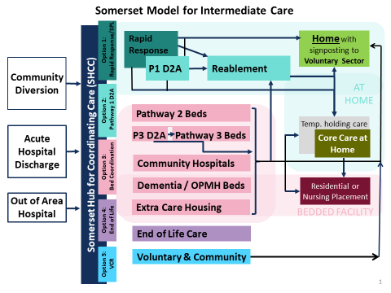

# The Somerset Hub for Coordinating Care

The ‘Somerset Hub for Coordinating Care’ (SHCC) was established in March 2020 as part of the Covid-19 response. Its primary purpose is to provide a central point for the allocation and tracking of intermediate care capacity to ensure equitable and consistent access across the county.

Accessed via a single phone number, it provides five options for the professional caller who wants to make a referral into an intermediate care service. It also is the place general practitioners (GPs) can access Somerset Primary Link Services (via Option 1) to arrange admission to acute hospitals or community hospitals for their patients, or to discuss the most appropriate alternative to admission such as RRS, H@H, UCR, DN, temporary placement.

**Somerset Hub for Coordinating Care**

**01749 836 700**

|  |  |  |
| --- | --- | --- |
| Hub Option | Description of Services | Email address for referral forms |
| Option 1 | * Acceptance criteria – any patient over 18 with a Somerset GP. * Exclusion criteria – under 18, acute mental health, dental, non somerset GP. * Neighbourhood Urgent Response Teams (Rapid Response, Urgent District Nursing[1], Falls service, Hospital at Home) * Somerset Primary Link services for GPs and other registered health professionals. Including SWAST, Social Care. * SPL service hours for referrals to option 1 are from 0800 – 2100 within the working hours of the Somerset Hub for Coordinating Care. * Referrals for RRS, UCR, DN’s, H@H, community hospital/acute setting or temporary placement while experiencing a short-term medical issue not requiring hospital setting. * Access to dedicated social worker for socially heavy referrals and collaborative approach. | [spn-tr.RRSRequests@nhs.net](mailto:spn-tr.RRSRequests@nhs.net) ?? is this still an option  primary.link@nhs.net |
| Option 2 | Discharge to Assess Home | **Send DST to:**  [D2Arequests@somersetft.nhs.uk](mailto:D2Arequests@somersetft.nhs.uk)  And[ASCMPHSupport@Somerset.gov.uk](mailto:ASCMPHSupport@Somerset.gov.uk) |
| Option 3 | Bed coordination  Service Hours 8-8  For patients in an acute setting who are MFFD but still require bedded option.  Pathway beds for those not requiring CH. | **Send DST to:**  BedRequests@SomersetFT.nhs.uk  **And**  [ASCMPHSupport@Somerset.gov.uk](mailto:ASCMPHSupport@Somerset.gov.uk) |
| Option 4 | End of Life coordination - for patients receiving Fast Track funding.   * Option 4.1: for symptom control and advice * Option 4.2: for care or equipment at home – dedicated team to support the service and service users throughout their time on the caseload. * Option 4.3: for care in a bedded facility | [EndofLifeCare@SomersetFT.nhs.uk](mailto:EndofLifeCare@SomersetFT.nhs.uk) |
| Option 5 | Call 07734 908506. *This will soon be replaced by a call to the SHCC Option 5 – ***This option 5 is now in place \*\*\** | <https://links.somerset.gov.uk/CommunitySPOCRequests> |

Referrals for intermediate care services can come from acute hospital wards, mental health units, bedded units, discharge lounges,, or from Accident and Emergency departments or primary care, SWAST, NHS 111 and community services who wish to avoid a hospital admission.

#### Overview of operating practice

|  |  |
| --- | --- |
| Operating Hours | 08:00hrs to 20:00hrs (21:00 for Option 1)  7 days per week |
| SHCC KPIs | Daily contacts by option  Average wait to answer call |

# Referral Sources into Intermediate Care

## Acute Supported Discharge: Referrals into Intermediate Care

The main source of referrals for intermediate care services in Somerset is for supported discharges from both Musgrove Park Hospital (MPH) and Yeovil District Hospital (YDH).

Following the NHSE/I discharge guidance, all decisions concerning support on discharge are now taken within a discharge lounge by a multi-disciplinary discharge team, and not on a ward. Ward staff only determine whether a medically fit patient requires support on discharge and if so, the responsibility for screening and decision making is transferred to the discharge lounge.

**Diagram 2: Supported Discharge and Diversion System – Supported Discharge**



**Option 5 – Voluntary and Community Sector**

The role of the multi-disciplinary team is to:

1. maximise a person’s opportunity to return home by exploring all options to use Pathway 0 before intermediate care support is considered.
2. maximise a person’s opportunity to return home by exploring all options to use Pathway 1 before intermediate care beds are considered
3. expedite the discharge process to avoid people staying in hospital longer than they need.

All Somerset system partner’s receive a Sitrep each day from the Somerset Hub for Coordinating Care (SHCC), to show what discharge capacity is available on each intermediate care pathway. A single discharge screening tool (DST) is used by all referrers, which also acts as the referral form into SHCC and onto the intermediate care services. As an alternative to the DST referral route, telephone call referral options are available for all services within option 1, option 2 and option 5.

#### **Screening and Discharge Processes**

Government discharge guidelines issued in March 2020 and re-issued in July 2022 provides guidelines to support timely discharges from hospital.

* Those who have been identified as no longer meeting the criteria to reside in hospital are moved to the discharge lounge when supported discharge capacity has been confirmed.
* Any decisions made in relation to supported discharge should be made in line with the Ethical Framework for Adult Social Care. There should be clearly documented evidence that the framework has been considered in all decisions.
* Special attention needs to be given to assessing those people who lack capacity to consent as part of the screening process. The Health Interface Service (HIS) supports socially complex discharges, including Mental Capacity Assessments, Deprivation of Liberty Safeguards and Court of Protection cases.

#### Discharge Lounges: Overview of operating practice

|  |  |  |
| --- | --- | --- |
| **Operating Hours** | 08:00hrs to 18:00hrs  7 days per week | |
| **Staff professions involved** | Discharge Facilitators  Registered Nurses  Health Care Assistants  Social Workers | Receptionist  Cleaners  Community Agents |
| **Acceptance criteria** | All patients identified as no longer meeting the criteria to reside in hospital and whom can be discharged same day. | |
| **Capacity** | Yeovil District Hospital: Circa 20 patients (up to 4 beds)  Musgrove Park Hospital: Circa 14 side rooms (for use for Covid-19+ patients) plus 18 seated area | |
| **Expected admission time frame** | As early as possible on day of planned discharge from hospital | |
| **Transport** | Booked by referring ward team, prior to arrival at discharge lounge | |
| **Expected Length of Stay** | Maximum 8 hours | |
| **Onward destinations** | Unsupported discharge:   * Pathway 0 - Home with voluntary and/or community sector (Hub option 5) or no formal support   Supported discharge:   * Home First Pathway 1 for assessment at home (Hub option 2) * Home First Pathway 2 or 3 as default option for bedded discharge (Hub option 3) * Specialist beds by exception (Hub option 3) * End of Life care (Hub option 4) | |
| **Discharge Lounge Key Performance and Monitoring Indicators** | 1. % discharges that are supported via DCL 2. Daily number of transfers to the lounge before midday 3. Number of supported discharges not delivered each day 4. Number of supported discharges delayed by over 24 hours 5. Number of times transport for supported discharges took more than 1hr and more than 3hrs to arrive | |

## Diversion: Referrals into Intermediate Care

Intermediate care services are also set up to provide support to people in the community who are in danger of needing an acute episode of care if a temporary health or reablement intervention is not provided. People can be supported to remain at home in circumstances where otherwise they may have been taken to Accident and Emergency (A&E). Intermediate care services can also be used when a person has already presented at A&E and an acute hospital admission is not deemed appropriate, but a health or care support need has been identified or is suspected.

These referral sources are known as ‘diversion’ routes as they divert people away from an admission to an acute hospital.

**Diagram 4: Supported Discharge and Diversion System – Diversion**



**Option 5 – Voluntary and Community Sector**

#### Diversion referrals are largely handled by Option 1 in the SHCC

Option 1 in the hub encompasses several functions and acts as a triaging service for community referrals that are being escalated for further support to avoid hospital admission. It is also for GPs to access an acute hospital bed directly using the Somerset Primary Link service.

Calls to this option are handled by clinicians who determine if support can be provided to keep the person at home or whether they need to be stepped up into a bed.

* For support at home- including Rapid Response, Urgent District Nursing and therapy referrals – the relevant referral form is completed on RiO by the SHCC call handler and is passed to the Rapid Response Team or local community nursing team
* All requests for non-acute bedded care are referred onto the bed co-ordination team accessed through Option 3 in the hub. The triaging clinician will manage the transfer and transport to the bed, not the bed co-ordination team.
* Requests for acute care from GPs are transferred to the relevant specialist at the acute hospital, the triaging clinician also arranges the transport to the acute hospital if this is required.

**Diagram 5: SPL Triage and Referral Process**

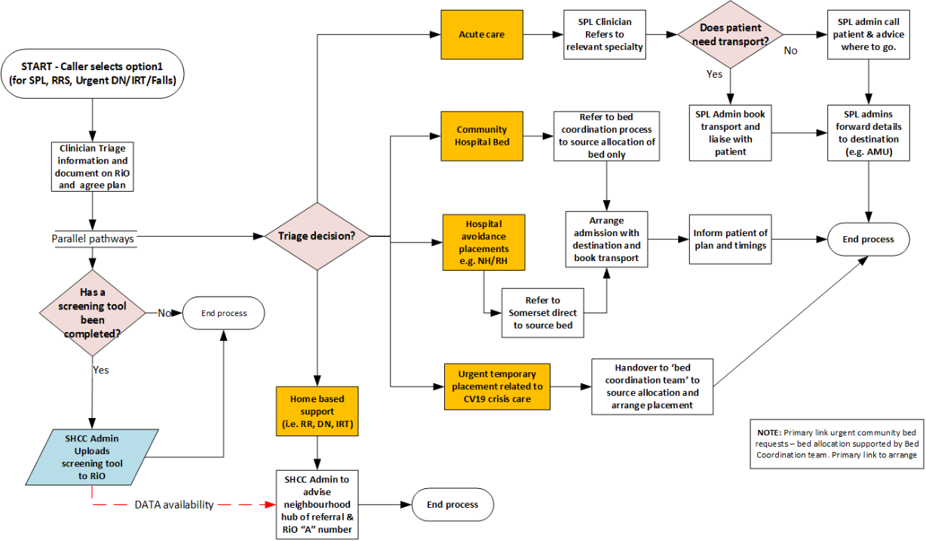

#### Sources of diversion referrals:

|  |  |
| --- | --- |
| South West Ambulance Service Foundation Trust (SWASFT) | SWASFT refer into Rapid Response for patients identified as requiring rapid support interventions where no acute clinical need for admission is identified and where support is needed to prevent an admission. |
| General Practice (GP) | GPs will largely use SHCC Option 1 to access the services provided by the Rapid Response team, including urgent rapid admission avoidance therapy referrals and option to refer onto community nursing teams.  GPs also use SHCC Option 1 to access ‘Somerset Primary Link’ (SPL) services to arrange admission to acute or community hospitals.  SPL service hours for referrals to option 1 are from 0800 – 2100 within the working hours of the Somerset Hub for Coordinating Care.  GPs can refer directly to end of life care via Option 4. |
| 111 (including CAS) | The Somerset 111 service is developing its Clinical Assessment Service (CAS). It is expected that it will have similar levels of access to SHCC as GP practices once the CAS service is developed. |
| Emergency Department Diversion | The multi-disciplinary diversion teams, which include adult social care and cover 7 days are working in the front door of Musgrove park and Yeovil District Hospitals to divert attendees away from an acute admission when one is not required.  This includes diverting people into Rapid response or intermediate care or supporting them and their carers with information and advice and utilizing local community support from the voluntary sector.  We are also linking with neighbourhood teams to offer support to frequent attenders and assessing those people early who go on to require admission to prepare for discharge early.  This work is linked to the ambulance diversion work and helps us identify those people for whom a conveyance could have been avoided.  Frailty Units are being developed that will take frail elderly people from A&E for assessment with the view to sending them home without admission. These units will use Rapid Response  and Adult Social Care where support to get someone home is needed. There is an aspiration for these units to eventually access intermediate care pathways directly through the SHCC. |

# **Intermediate Care Pathways**

## **Neighbourhood Teams and Rapid Response (Hub Option 1)**

Neighbourhood Urgent Response Teams were set up as part of the Covid-19 response to provide an enhanced, integrated and local urgent community care offer to deal with an expected increase in demand. There are four Neighbourhood teams operating in Somerset localities – Bridgwater and North Sedgemoor, South Somerset, Taunton and West Somerset and Mendip – aligned to the existing Adult Social Care locality teams. Accessed through the SHCC, the new service provides a single point of access and inter-service approach for Rapid Response (which includes rapid therapy input) and Urgent District Nursing.

#### Neighbourhood Teams: Overview of operating practice

|  |  |  |
| --- | --- | --- |
| Operating Hours | Each Neighbourhood Hub will operate 0800 to 2200hrs 7 days a week. | |
| Services involved: | District Nursing  Integrated Rehabilitation Teams (IRT)  Older Persons Mental Health | Pharmacy  Primary Care  Adult Social Care |

#### District Nursing and IRT

Referrals for district nursing and community therapy are received into the Neighbourhood Hub several ways:

* Through the SHCC Option 1. The triaging clinician completes the relevant referral form on RiO using information sent by email or given over the phone and informs the hub of the document number.
* Directly to the neighbour hub from patients, carers, GPs, or other community sources by phone. The Neighbourhood Hub responder fills in a Community Services Referral Form on RiO based on the conversation.
* Directly from patients, carers, GPs or other community sources by email. The Neighbourhood Hub responder uses the information to complete or review the referral form and uploads it onto RiO.

For IRT referrals (non-urgent therapy) the hub creates a referral on RiO which is added to the team worksheet. The team reviews the referral and schedules the visits or contacts the referer if it is not appropriate.

District nursing referrals are opened by the hub on RiO and added to the team’s daily planner. Urgent referrals are accompanied by a phone call to the co-ordinator to be assigned. District nursing referrals are also received directly into neighbourhood hubs from the hospitals, bypassing the SHCC contact centre.

#### Falls Service

The Falls Service supports people who are at risk of falls by helping them to identify the underlying cause and to access services that can help them manage their care and support needs. This reduces demand for acute services, promotes independence and reduces the risk of frailty.

The service sits within Somerset Primary Link and is accessed through SHCC Option 1 where a specialist nurse triages referrals:

* If the person is at immediate risk, the nurse completes a referral to Rapid Response.
* If the person requires urgent rehabilitation, the nurse completes a referral to the local IRT team through the Neighbourhood Hub.
* If the person requires non-urgent therapy, the nurse completes a referral to the county-wide IRT service and offers immediate advice as required.
* If none of the above are true and there was a medical reason for the fall, the nurse liaises with the GP to support ongoing falls management.

**Diagram 6: Falls Service Triage and Referral Process**

#### cid:image002.png@01D61A20.2A9546B0

#### Rapid Response

The Rapid Response Service is the most significant diversion service in intermediate care. The service aims to:

* Prevent unnecessary hospital admissions by providing a credible alternative to admission for frail older people who do not need any acute medical intervention but would be admitted to hospital without immediate additional support at home. Rapid Response is a countywide service that operates from 4 bases in East and West teams.
* Provide urgent admission avoidance therapy interventions
* Support discharges from Hospitals

Referrals are received from the community, emergency services and from turnaround at A&E, Minor Injury Units and Frailty units. Patients remain under the care of their GP.

#### Rapid Response: Overview of operating practice

|  |  |
| --- | --- |
| **Operating Hours** | The main support service operates 7 days a week, from 0800 until 2300hrs, with overnight sitting/visits.  Referrals are only received between 0900 to 2100hrs, 7 days per week. Outside of these hours they will need to call 111 or 999 if clinical support is needed  Urgent therapy referrals are only received between 09:00 – 20:00 7 days a week |
| **Staff professions involved:** | * Clinical Supervisors oversee caseloads and take referrals and are either registered nurses or registered AHPs. * Senior therapy team (Occupational therapists and physiotherapists) * Registered Nurses working alongside clinical supervisors * Therapy assistants * Senior healthcare support workers * Teams of Band 3 Health Care Support Workers |
| **Acceptance criteria** | Exclusions:   * Patients in residential/nursing Homes * Patients in acute mental health crisis |
| **Accepts referrals from:** | For admission avoidance patient referrals will be accepted from GPs, Primary Care clinicians, SWAST clinicians, Out of Hour GP service, and acute hospital A&E and Frailty units. |
| **Capacity** | The maximum capacity of the Rapid Response Service at any one time is variable due to the changing complexity of the caseload. The services aims to support an average of 20 new referrals each day. |
| **Expected admission time frame** | Response time <2 hr from the time at which the Rapid Response Service receives the referral, or 2 hours from leaving the hospital. |
| **Transport** | Booked by referring site |
| **Expected Length of Stay** | Maximum 3 days |
| **Onward Destinations** | * Discharge, no support needed * Discharge with support from Community Healthcare teams, voluntary sector and/or * Home First Pathway 1 reablement - bypassing need for D2A assessment (via Hub option 2) * Escalation to Home First Pathway 2 and 3 beds (via Hub option 3) * End of Life care (Option 4) |
| **Key Performance and Monitoring Indicators** | 1. Length of stay 2. Number of patients not admitted to service due to capacity 3. Number of referrals by source and Covid-19 status 4. 2 hour resource times 5. % patients readmitted to hospital 6. % patients who are referred to core care |

#### Rapid Response Processes

* After receiving a referral, the Rapid Response team will visit the person at home for an initial assessment
* If they decide the person is not safe to be at home, they implement the escalation plan.
* If the person is safe at home, they put a plan in place to meet their immediate care needs, including liaising with other relevant services. An Urgent District Nursing and/or therapy assessment may also take place the same day.
* Within the period of care, the service assesses the person’s ongoing care and support needs and can carry out physiological observations as required.
* Using this information, the service aims to discharge the person within 72 hours with no further support, or a referral into other community services (neighbourhood teams) or Adult Social Care.
* Requests for care packages – whether new packages or increases to existing packages – are made to the Sourcing Care team via Somerset Direct. The request should be actioned with 48 hours, with the care provided reviewed after 2 weeks.
* If the person meets the criteria for D2A, the worker completes the screening form and makes a referral to the D2A team as per diagram below

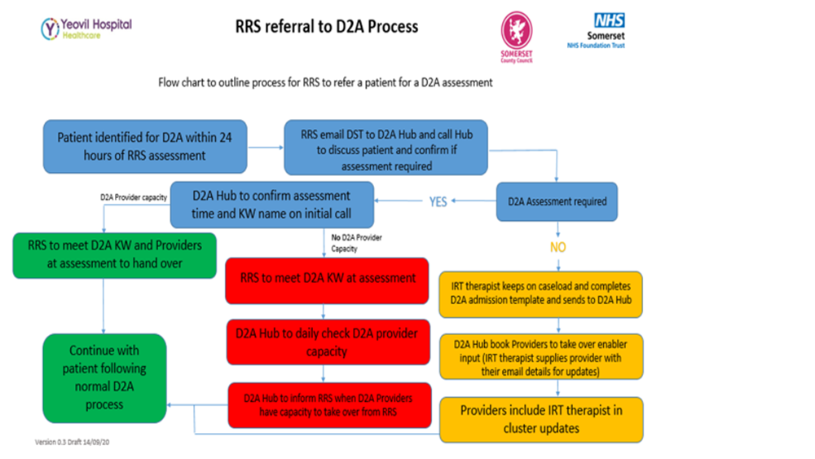

## **4.2 Intermediate Care Pathway 1 - Discharge to Assess (Hub Option 2)**

Home First Pathway 1 is a Discharge to Assess (D2A) service and is the route for all supported discharge home, except for Fast track End of Life. A D2A model ensures no assessment for ongoing homecare care happens in an acute hospital setting but happens in a person’s home instead. This enables speedy discharge and prevents the overprovision of long-term care.

Home First Pathway 1 has two component parts:

1. Part 1 D2A: Up to 72-hour supported therapy assessment.
2. Part 2 Reablement: Short term reablement following the assessment period.

A person is eligible for Home First Pathway 1 if they:

* Are safe to be at home between care visits,
* Are suspected to have daily care and support needs,
* May need a short period of night-time support to settle home and further understand ability to manage at home,
* May have an existing core care package of care but need additional support to understand needs where it is not clear if an increase is required, and
* Are not eligible for End of Life.

A person does not need to have reablement potential to be eligible for Pathway 1 and they could be suspected of needing a package of core care immediately on returning home. The difference with a D2A model is that a person is discharged home before any assessment or decision is made about their long-term care needs.

#### **Intermediate Care Pathway 1: Overview of operating practice**

|  |  |
| --- | --- |
| **Operating Hours** | 08:00hrs to 20:00hrs  Mon – Friday 5 days per week  10:00 to 18:00  Weekends |
| **Staff Professions involved** | Occupational Therapists  Reablement Assistants  Adult social care practitioners  Physiotherapist  Administrators  Coordinators  *Community Mental Health Nurse* |
| **Acceptance criteria** | * Safe to be at home between care visits * Suspected to have daily care and support needs that their existing support may not be able to meet * Not eligible for End of Life. |
| **Capacity** | As of December 2022 D2A / Option 2 aspire to support 10 new discharges per week day and 5 per weekend |
| **Expected admission time frame** | The D2A service aspire to admit people on to their service within 24hrs of referral all patients that require it will be met at their home on discharge |
| **Transport** | Referrer to organise transport |
| **Expected Length of Stay** | Part 1 D2A: Expected care model 72hrs from point of discharge (in alignment with Rapid Response)  Part 2 Reablement: Reablement can continue up to 6 weeks from admission to service but is led by individual goal attainment. The majority of patients are discharged within 2 weeks |
| **Onward Destinations** | * Discharged with no further support * Discharged with some voluntary sector support * Continue with reablement care (if coming from D2A part) * Referred to ongoing care and support |
| **Key Performance and Monitoring Indicators** | 1. Number of referrals by source and status 2. Number of discharges same day and 24hrs 3. Daily Key Worker and provider capacity 4. Length of stay on D2A 5. Length of stay on reablement 6. % discharged from D2A after first assessment 7. % D2A than continue to reablement 8. % reablement discharges that continue to core care 9. % escalations 10. % that achieve their goals |
| Provider KPIs | 100% daily updates for all patients (7 days) using RiO (where this is not possible email update.)  100% daily attendance on cluster calls.  % of block utilization – weekly reporting  0 declined referrals – weekly reporting unless at 100% utilization or any of below:  % delay days (moving on from D2A)  % pathway acuity – double ups  % supported to VCSE  90% positive client feedback / survey (Universal D2A survey)  ? 14 days average length of stay |

#### Referral and Booking Process

The service receives discharges from bedded care facilities including acute and community hospitals and Home First Pathway 2 and 3 beds. Referrals also come into Home First Pathway 1 from services that are focused on preventing admissions to hospital, such as Rapid Response, where further support is required in a period of reablement. The service is not a bridge for a longer-term package of core care.

All referrals are received via the D2A coordination HUB. Referrals can be made via the telephone referral process direct with the HUB or completing the service discharge to assess referral form and sending to the HUB for triage. The D2A co-ordinator then uses ‘Capacity Tracker’ to schedule a visit from a provider and key worker.

**Diagram 7: D2A End to End Process**

For the process for stepping down people from pathway beds onto D2A see ‘Stepping down from an intermediate care bed onto Home First Pathway 1’ on page 25.

#### Part 1: Discharge to Assess

Following discharge, the assigned key worker will meet the person on their arrival home unless previously arranged to complete the assessment at an alternative time. This is done alongside a member of staff from the provider who will be conducting the reablement visits. The assessment checks whether the person is safe to be at home and identifies any equipment need. If the person is unsafe to be at home, the key worker will agree escalation with a D2A senior then arranges transfer to bedded care through Option 3 in the SHCC. The key worker will assess if the individual is safe to be left while awaiting transfer or arrange for someone to wait with the patient which may be the keyworker until the transfer to the bedded facility occurs. The patient is then discharged from D2A.

If the person is safe at home, the key worker confirms the frequency of reablement visits with the provider. The provider carries out the agreed reablement visits, recording all visits on RiO. A key worker may provide some visits if the provider is unable to.

Within the 72-hour assessment period, the key worker makes a decision to:

1. discharge the person with no further support.
2. discharge the person with some voluntary sector support,
3. continue with reablement care, or
4. refer them to ongoing care and support.

#### Part 2: Reablement

Short term reablement is a secondary provision within D2A. The value of this additional support is to complete or consolidate realistic goals that can be achieved over a short period and therefore reduce or negate any funded longer-term care.

If the key worker decides within the 72-hour window that a person has reablement potential, the key worker, provider and person set reablement goals and an estimated date of discharge is recorded on RiO. Reablement care visits by the provider and/or key worker continue, with progress recorded on RiO. All RiO reporting will be completed by the key worker and provider

The key worker and provider relationship will continue throughout this period. They will:

* Work closely with the relatives, enablers and carers within Somerset to support the achievement of reablement goals and onward self-management.
* Work as a partnership with access to a registered practitioner for development of specific treatment or urgent escalations.
* Quickly activate care reductions or refer to Community Neighbourhood teams where longer-term solutions can be managed.
* Manage a robust discussion about discharge where support is no longer needed.

#### Moving on

Either during the initial assessment period or following reablement care, the key worker decides about ongoing care:

* If the person needs no ongoing support above their pre-admission support, they are discharged from the service.
* If the person needs some additional support, the key worker completes the relevant referral (e.g. to a voluntary sector service) and discharges the person.
* If the person needs ASC funded long-term care, the key worker sends a professional referral to the ASC Community Team via Somerset Direct. Ongoing care should be sourced in 48 hours, during which time care visits continue.
* If the person needs support to find a care and support service that they are funding themselves the Key Worker will offer the involve and support of Community Agent.

The process for moving people to ongoing care, either from D2A or from reablement, is outlined on the next page.

#### Waking Nights Service

The Waking Night Service can be used where it is clear someone is safe at home between care visits during the day but further understanding of night routines is required to be sure they are safe at night. It can be booked for up to 2 nights to enable safe discharge and allow for assessment of ongoing night needs.

Somerset have commissioned 7 nights per night from the Waking Night Service to support discharges home from acute hospitals and step-downs to D2A.

Night provision is booked with the completion of the service referral form . The form is sent to EOL HUB email Option 4 who confirm booking via return email. The online availability calendar can be viewed to also confirm booking.

Referrals are only available on the day of discharge, 8-6 during the week and 9-5 weekends and BH’s. . The service will respond to support outside of these times in exceptional circumstances. Any spot requests will need ASC sign off for funding approval and will be sourced via Sourcing Care Service.

Those who are safe to be at home in the day but may be unsafe at night are eligible. The service supports:

* New referrals from hospital into D2A.
* Step-down referrals from a pathway bed to D2A.
* Referrals from those discharged with a restarted package of care from acute hospital.
* New referrals from Rapid Response for admission avoidance within normal working hours.

Iona will need to check if the boundaries remain correct.

**Map of County and district boundaries for providers:**

The link to the live map will show the 4 boundaries that providers will work to, alongside a flexible approach to supporting discharges up to 5 miles outside of these areas.

The live link will allow providers to scroll in on the detail for each area. The Picture below is the full view of the Somerset area and boundaries.

<http://www.somersetintelligence.org.uk/maps.html>

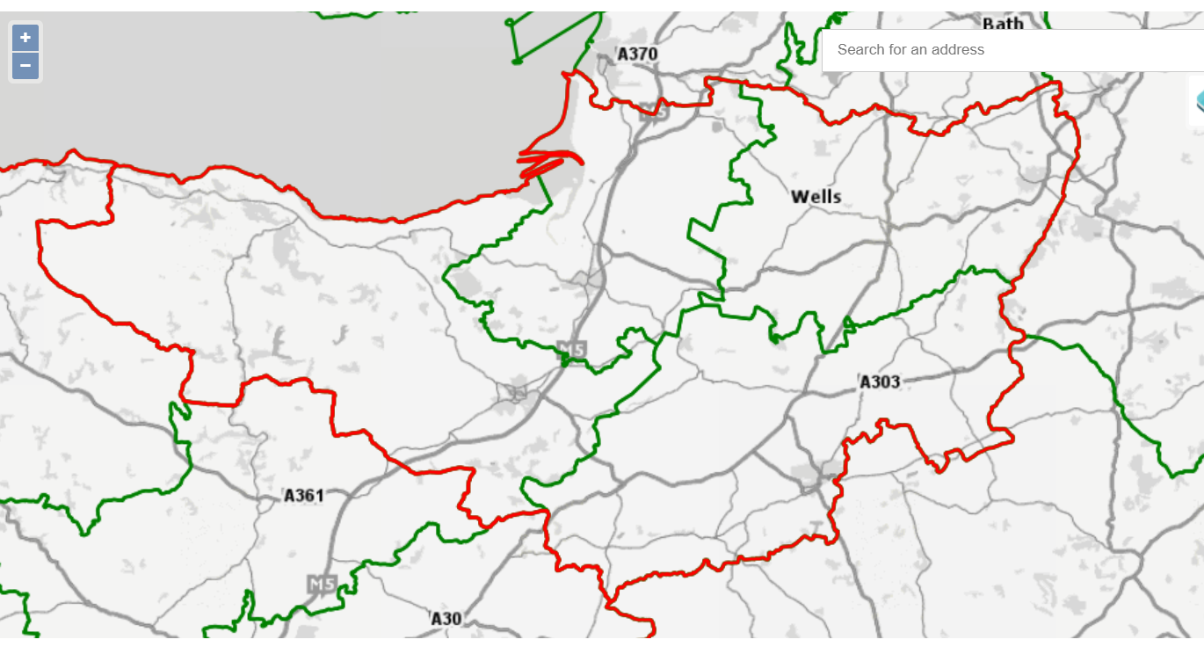

COVID will need updating to new guidelines

D2A can support patients to return home who have been COVID exposed or Covid infected. Time frames of being able to support patients under our providers must be advised at time of referral due to the changing guidance around COVID 19 and the providers own guidelines.

## COVID 19 - Supporting Discharges into D2A Home First Pathway 1

Categories of discharges across the system

The individuals in the categories below will all be appropriate for discharge, may be still be infectious, they are appropriate for care outside the hospital setting but would need the 10 day period of isolation and all staff would need to comply with hand hygiene and full PPE.

Discharge home destination will be supported for the following groups all of which require a **14 day isolation period** :

Patient is medically fit for discharge

* Positive test in last 48 hrs and afebrile (no fever) for 48 hours without use of medication
* Positive test and free of fever for the last 48 hrs without the use of medication
* Positive test with COVID symptoms and medically fit / suitable to transfer home
* Negative test but recent exposure to a known Covid positive patient within inpatient setting

If patients have been exposed to Covid they will be tested within 2 days **of discharge**. These results must be communicated with the provider via the D2A hub.

Household contacts should not be in the Clinically Extremely Vulnerable group

If a person is discharged following a negative swab and there is a subsequent positive test in the discharging bay from a patient that was present during their admission within a 14 day timeframe, the acute hospital must communicate this to the D2A hub. The hub must then inform the relevant provider.

Acute Swab process for COVID 19

The Swab process for all patients in Somerset Acute Hospitals is detailed below. This process is also followed within Community Hospitals.

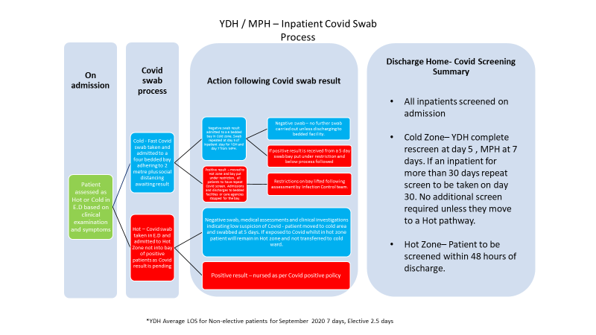

## Bedded Care (Hub Option 3)

When a person is deemed unsafe to be at home in between care visits, a temporary bed in the community should be sought until they are re-abled to return home. There are different types of temporary beds and clear guidance is in place as to which bed is the most appropriate choice for a person. This is set out in the diagram below.

**Diagram 9: Intermediate Care Beds – Definitions and Hierarchy of Use**



The default option for most people should be either to a **Pathway 2 or Pathway 3 bed**. These beds give a person the best chance of optimising their independence and are specifically set up to rehab and re-able people to the point where they are safe to return home. On the occasions where this is not possible, assessments are completed for residential or nursing placements.

**Community hospital beds** are to be used for the specific exceptions of stroke or neurological rehabilitation, or when someone requires further clinical care or significant medical support following an acute episode of care.

They should only be used for general rehabilitation purposes if all pathway beds are full. Similarly, **interim beds** are only to be referred to directly when there is a social reason why someone cannot immediately return home.

Temporary **Older Person’s Mental Health (OPMH) Beds** are available to support people with significant cognitive impairment or who have specific behavioural needs to leave hospital sooner. This environment provides people with a non-acute hospital setting in which their longer term care needs can be evaluated. PW2 and PW3 beds must have been considered and ruled out before considering OPMH. OPMH beds are located within the PW3 sites.

People who are **Covid-19 positive** and their normal place of residence is a residential or nursing home or they live with a vulnerable person who is shielding will require temporary transfer to a community hospital side room.

When a person needs a **bed for End of Life care** the referrer should access this provision through ‘Option 4: End of Life’ in Somerset Hub for Coordinating Care. They will then be redirected to the bed coordination team who will identify the most appropriate bed for the person.

Interim beds are not routinely used. They may be considered in high levels of escalation with authorisation from the Director or Deputy Director for Adults (SCC).

#### Referrals routes and booking process

Referrals for intermediate care beds will come from acute hospital discharge lounges or as escalations from either Rapid Response or the Discharge to Assess part of Home First Pathway 1. These escalations occur when a person at home is deemed unsafe to remain and needs further support on a bedded pathway to return to a point where they are safe to be at home.

For acute hospital discharges, the discharge lounge team will be responsible for making the referral decision as to which type of bed is appropriate for the patient. These decisions will be supported by in-reach nurses who will be responsible for making the referral and booking the bed through Option 3 Bed Coordination within Somerset Hub for Coordinating Care.

The process for booking a bed is set out in the flow chart below.

**Diagram 10: Process for Booking Bedded Care**



#### Monitoring and management of pathway beds –

All beds across the community settings managed using the same model of assessment and oversight.

**Diagram 11: Process for Monitoring and Management of Pathway Beds**

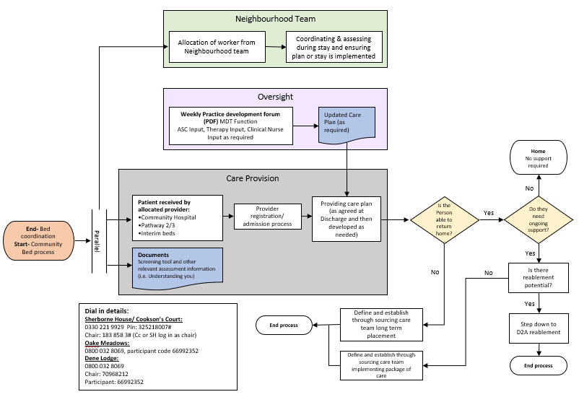

#### Moving on from intermediate care beds

**Stepping down from an intermediate care bed onto Home First Pathway 1**

A person should be ‘stepped down’ from an intermediate care bed as soon as they are deemed to be safe between visits. They can then continue their journey towards independence at home with the reablement part of Home First Pathway 1. For step downs from pathway beds it is expected that the assessment part (D2A) of Pathway 1 would not need to be repeated, as this information would have been gained by the persons pathway therapy key worker whilst they have been in bedded care.

The Pathway 2 or 3 therapist, wherever possible, should do the initial discharge visit home onto Pathway 1 and set up the reablement goals with the D2A provider. If the person is well known to IRT or the ASC OT / neighbourhood teams then they can act as the keyworker during the pathway 1 phase. If the pathway 2/3 or community IRT/neighbourhood teams are unable to release a therapist to do this, then the D2A key worker should conduct the discharge visit and set the goals.

A robust verbal handover between the Pathway 2 and 3 therapist and the allocated key worker should be completed following the discharge visit (or prior if the discharge visit is to be carried out by the key worker).

|  |
| --- |
| **Referral checklist to Home First Pathway 1 from Pathway 2 and 3**  The check list will help identify if a step-down is the most beneficial option.   1. Is the aim for home? 2. Is the person safe between visits? 3. Can the person manage between visits independently if living alone or with assistance of one +/- equipment? 4. Does the person have a clear plan with measurable and realistic goals that has demonstrated progression on the pathway they are in? 5. Can the person complete the goals that have been set at home, within a short time scale?   If this check list is yes to all questions it is likely that a step down is the appropriate follow-on pathway. |

**Moving on to a package of care at home**

If a person is safe to be at home and has care needs but has clearly reached their reablement potential, they will need core care. The therapist or HIS ASC worker on Pathway 2 or 3 should arrange a home visit to do the assessment. This will establish if they are safe to go home and will help the pathway therapist /ASC worker understand what home looks like, establish what they need and source the care. All core care is reviewed at 2 weeks by the ASC locality team so it can be reduced or increased or stopped and a Care Act Assessment completed if necessary. Assessment for core care should not be completed in a bedded facility.

**Moving on to a residential or nursing placement**

Occasionally it will be clear that the person cannot be re-abled to a point where they are safe at home. In these cases, the Care Act Assessment for a permanent residential or nursing placement should be completed by the HIS ASC worker associated with the pathway setting. These assessments should ideally only take place from a pathway bed and not from an acute or community hospital bed.

**Moving on from an interim bed**

People who have been moved into an interim bed during times of escalation will require a community ASC worker to work with them to support them with their longer term care needs.

#### Pathway Beds: Overview of operating practice

|  |  |  |
| --- | --- | --- |
| **Pathway Beds** | | |
| **Operating Hours** | 24 hrs 7 days per week | |
| **Staff Professions involved** | Registered Nurse  Health Care Assistant  Reablement Assistant  Occupational Therapy support  Social Worker | Physiotherapy support  Limited medical support (GP or Outreach)  Associate Specialists and Advanced Nurse Practitioner (for Pathway 2 beds in community hospital) |
| **Acceptance criteria** | Accepts referrals via SHCC (Option 3 Bedded Care)  Discharge Screening Tool completed by referrer  **Pathway 2** - The patients are unsafe between visits and require further reablement in a bedded facility  **Pathway 3** - The patients are unsafe between visits and require slower stream reablement in a bedded facility or it is considered this person is suitable for permanent care placement. | |
| **Capacity** | Pathway 2 beds - 62 beds + 5 beds in Rachael House Minehead mainly for West Somerset  Pathway 3/OPMH beds – 35 beds (20 Oake Meadows, 15 Glastonbury Care Home) | |
| **Expected admission time frame** | Within 24hrs of the bed being declared available | |
| **Transport** | Referrer books transport | |
| **Expected Length of Stay** | **Pathway 2** – Reablement beds – 14-16 days on average  **Pathway 3** – Reablement beds – 30-34 days on average | |
| **Onward Destinations** | * Discharged home with no support * Discharged home with D2A * Discharged home with a package of care * Discharged to a residential or nursing placement | |
| **Key Performance and Monitoring Indicators** | 1. Number of people waiting for a bed 2. Number of referrals by source and Covid-19 status 3. Number of admitted into bed by source 4. % bed occupancy 5. Length of stay 6. % escalations 7. % service users who are discharged home 8. % service users who are discharged home with less support than prior to admission | |

#### Community Hospital Beds: Overview of operating practice

|  |  |  |
| --- | --- | --- |
| **Operating Hours** | 24 hrs 7 days per week  All admissions, where possible, should take place within reasonable hours (i.e. 08:00. to 20:00) 7 days per week. Admissions outside of these hours will be facilitated to support acute hospital admission avoidance, or if system partners are under pressure and require support. | |
| **Staff Professions involved** | Registered Nurse  Health Care Assistant  Occupational Therapy support  Social Worker  Receptionists  Chaplains | Physiotherapist support  Advanced Nurse Practitioner  Limited medical support (dependent on site)  Hotel services |
| **Acceptance criteria** | Community hospital has the following functions:   * Supports general community health conditions (largely medical), with some End of Life care and system escalation to support the regional acute settings. * Provides stroke rehabilitation care * Provides neurological rehabilitation care - managed directly by acute provider * Site of Pathway 2 beds   Admission criteria:   * Patients notes are complete and ready, including MAR chart * Minimum 3 days’ supply of medication * If recently commenced on warfarin regime, minimum 3 days of dosing is required * Confirmation that patient is medically stable and evidence of plan. * Patient has confirmed diagnoses * Complex medical investigations that must be conducted as an inpatient are not required. * Clear purpose of assessment, treatment, rehabilitation, care or on-going management plan. * Clinical risk has been assessed by the referrer and considered appropriate to support   The Somerset system will be responsible for providing adequate notification of patients requiring onward care and will be in continual liaison with the receiving community hospital to ensure a seamless patient transfer. | |
| **Capacity** | Circa 200 – including:   * 44 pathway 2 beds * Circa 40 stroke and neurological rehabilitation beds | |
| **Expected admission time frame** | Within 2hrs of the bed being declared available | |
| **Transport** | Referrer books transport | |
| **Expected Length of Stay** | Approximately 2 weeks but variable according to clinical need | |
| **Onward Destinations** | * Discharged home with no support * Discharged home with D2A * Discharged home with a package of care * Discharged to a residential or nursing placement or Extra Care Housing | |
| **Key Performance and Monitoring Indicators** | 1. Number of people waiting for a bed 2. Number of referrals by source and Covid-19 status 3. Number of admitted into bed by source 4. % bed occupancy 5. Length of stay 6. % escalations 7. % service users who are discharged home 8. % service users who are discharged home with less support than prior to admission | |

#### OPMH Provider Beds: Overview of operating practice

|  |  |  |
| --- | --- | --- |
| **Operating Hours** | 24 hrs 7 days per week | |
| **Staff Professions involved** | Based on staffing a 15 bedded unit:  1 Registered Nurse 24 hours a day 1 Senior and 2 Care Assistants: 08:00 to 20:00  2 Care Assistants 20:00 to 08:00 Housekeeper 30 hours a week Laundry assistant 15 hours per week Kitchen assistant 42 hours a week Resident activities 15 hours a week Unit manager 40 hours a week |  |
| **Acceptance criteria** | Temporary register with the local GP Practice  Only to be used in exception when a person’s mental health condition means that their full needs are not able to be met within the pathway 2 or 3 beds.  Accessed via Hub option 3 with ASC managing referral from discharge lounges where possible. | |
| **Capacity** | Glastonbury Care Home (Variable as PW3 and OPMH beds are interchangeable)  Oake Meadows (Variable as Pw3 and OPMH beds are interchangeable) | |
| **Expected admission time frame** | Within 24 hrs of referral | |
| **Transport** | Referrer arranges transport | |
| **Expected Length of Stay** | Up to 1 month | |
| **Onward Destinations** | * Discharged home with no support * Discharged home with D2A * Discharged home with a package of care * Discharged to a permanent residential, nursing placement, SRC or OPMH | |
| **Key Performance and Monitoring Indicators** | 1. Number of people waiting for a bed 2. Number of referrals by source 3. Number of admitted into bed by source 4. % bed occupancy 5. Length of stay 6. % escalations 7. % service users who are discharged home vs permanent placement | |

#### Interim Beds: Overview of operating practice

|  |  |  |
| --- | --- | --- |
| **Operating Hours** | When in use - 24 hrs 7 days per week | |
| **Staff Professions involved** | Registered Nurse  Health Care Assistant  Social Worker | Limited medical support (GP or Outreach)  IRT in-reaching as required |
| **Acceptance criteria** | Only to be used in exception when there is extreme pressure in the system and the interim bed usage has been authorised by the SCC Director / Deputy Director of Adults.  Used when pathway beds and community hospital beds are full.  Accessed via Hub option 3 with ASC managing referral from discharge lounges where possible. | |
| **Capacity** | Variable | |
| **Expected admission time frame** | Within 24 hrs of referral | |
| **Transport** | Referrer arranges transport | |
| **Expected Length of Stay** | Variable (2-6 weeks) | |
| **Onward Destinations** | * Discharged home with no support * Discharged home with D2A * Discharged home with a package of care * Discharged to a residential or nursing placement | |
| **Key Performance and Monitoring Indicators** | 1. Number of people waiting for a bed 2. Number of referrals by source 3. Number of admitted into bed by source 4. Length of stay 5. % escalations 6. % service users who are discharged home vs placement 7. % service users who are discharged home with less support than prior to admission | |

**Guidance for stepdown of infection control precautions for lab confirmed COVID-19 inpatients**

**New process – 22/12/20**

Clinical Leadership Group approved the new process for stepping down of infection prevention and control (IPC) precautions for COVID-19 inpatients on 17/12/20. The process relates to Somerset Foundation Trust inpatients and may be implemented with immediate effect.

**What has changed?**

Until now, prior to stopping IPC precautions, a negative COVID test was required for all patients. A number of patients have prolonged viral shedding and evidence demonstrates that this does not represent ongoing infectivity. Therefore, for most patients, IPC precautions can be safely stopped and patients stood down 14 days after first positive swab (day 15) without routine viral clearance. Viral clearance will only be required for 3 groups of patients: those who have been in critical care, severely immunosuppressed or those having aerosol generating procedures (AGPs).

**A senior clinical decision maker with responsibility for the individual patient’s care must ensure that the clinical assessment has been conducted and that this is recorded specifically in the medical notes and on the discharge summary.**

**New Stepdown Process**

Patients that **have not** required critical care / **are not** severely immunosuppressed / **are not** having AGPs – may be stood down at day 15 after first positive test **without viral clearance** testing, providing there has been clinical improvement (at least some respiratory recovery) and afebrile for 48 hours without use of medication. Any discharges of a patient who has at some point during the admission been Covid positive into a **new care setting** cannot be discharged into a home that is experiencing an active outbreak. Discharges can however be provided for a patient who has at some point during the admission been Covid positive into a care setting if the patient is being discharged back into the care home from which they had been admitted. There must also be due consideration given to the homes ability to provide effective safe care if they are subject to a significant outbreak.

**Critical Care Patients**

Patients who have required critical care may only be stood down at day 15 if:

* Clinical improvement and afebrile for 48 hours

**AND**

* One negative sputum test (if unable to gain sputum, 1 negative nose & throat swab)

If they remain positive, infection control precautions must remain in place and the patient retested at 7 day intervals until a negative test is obtained or until day 35 since first positive test when they may be stood down without any further testing.

**Patients having AGPs**

Patients having AGPs may only be stood down at day 15 if:

* Clinical improvement and afebrile for 48 hours
* One negative sputum (if unable to gain sputum, **2** negative nose & throat swabs taken 48 hours apart)

If they remain positive, infection control precautions must remain in place and the patient retested at 7 day intervals until a negative test is obtained or until day 35 when if there is ongoing clinical improvement the patient may be stood down without further testing.

**Immunosuppressed Patients**

Patients that are severely immunosuppressed as per definition below may only be stood down at day 15 if:

* Clinical improvement and afebrile for 48 hours
* One negative sputum (if unable to gain sputum, 1 negative nose & throat swab)

If they remain positive, infection control precautions must remain in place and the patient retested at 7 day intervals until a negative test is obtained or until day 23 after first positive test, when the patient may be stood down without further testing

## End of Life Care (Hub Option 4)

When a professional referrer needs to access support for someone at the end of their life, they can access the Somerset End of Life Care Coordination Centre via Option 4 of the SHCC.

The caller is given a further 3 options after selecting Option 4:

4.1: Symptom control and/or advice from St Margaret’s Hospice

4.2: Request a package of care or equipment at home through the End of Life care coordination centre

4.3: Request a bedded facility

#### Option 4.1: End of Life symptom advice and support

The symptom advice service is managed by St Margaret’s Hospice and can be accessed 24 hours a day, 7 days a week. The advice line is answered by a trained nurse who will be able to provide advice and support to anyone (including family, carers, health and social care professionals) caring for a patient with a palliative diagnosis.

A direct contact number to St Margaret’s Hospice is also provided to the individuals caring for a patient with a palliative diagnosis. In which case, access to the symptom and advice line will bypass the Somerset End of Life Care Coordination Centre.

Option 4.2: End of Life care at home

The primary role of Somerset End of Life Care Coordination Centre is to arrange home care and equipment across Somerset for patients at the end of their life who may already be at home or wish to be discharged home.

Patients are referred to the End of Life Care Coordination Centre from the acute trusts using the Single Referral Form or from the Community setting using Section 1 and 2 of the Care Order Form.

Once the referral has been received, it is triaged by a clinician and funding is agreed. A request to fill a package of care is then sent out to contracted providers. Once a provider has been sourced and secured the End of Life Care Coordination Centre will inform the referrer and patient or next of kin.

The Centre is also responsible for coordinating and allocating waking nights sits via Marie Curie. This includes the waking night sits for D2A, Rapid Response and Adult Social Care (via the Sourcing Care team).

As part of the Covid-19 response, the clinicians working in the End of Life Care Coordination Centre are responsible for triaging and approving funding requests for End of Life patients at home as well as those in nursing home placements.

#### Option 4:3 End of Life care in a bedded facility

Bedded care for End of Life can be accessed through Option 4.3 through the hub where the bedded facility request will be taken by the bed coordination team.

#### Overview of operating practice

|  |  |  |
| --- | --- | --- |
| **Operating Hours** | Hub receipt of referrals – 8:00-20:00, 7 days a week | |
| **Staff professions involved** | Administration staff | Registered Nurses |
| **Acceptance criteria** | Acute Hospital referrals – via SHCC Single Referral Form  Community referrals – via Continuing Healthcare (CHC) Form  Meets home care requirements, (i.e. not safe between visits, safeguarding concerns) or bedded care requirements, as applicable | |
| **Capacity** | Generally able to provide for approximately 20-50 patients depending on care need (based on historical patient load)  Variable care packages delivered depending on need – broadly maximum delivery up to 4 x visits per day, plus a carer night sit (10pm -7am) | |
| **Expected admission time frame** | Packages of care generally able to be established the same day or within 24 hours – variable during peak demand | |
| **Transport** | Acute hospital referrals - referrer will arrange transport to home setting  Nursing home settings – End of Life Care coordination Centre staff will arrange transport | |
| **Expected Length of Stay** | Generally, length of stay is approximately 31-32 days | |
| **Key Performance and Monitoring Indicators** | 1. Referrals by source 2. Referrals by Covid status 3. End of Life care packages started by referral source 4. End of Life care packages requested but not started by the end of the day 5. Delay of over 24 hours in starting care package 6. Open caseload 7. Length of stay | |

**Diagram 12: Process for Booking End of Life Care**



**Diagram 13: Process for Monitoring and Discharging from End of Life Care**



**Diagram 14: Process for Triaging End of Life Calls**

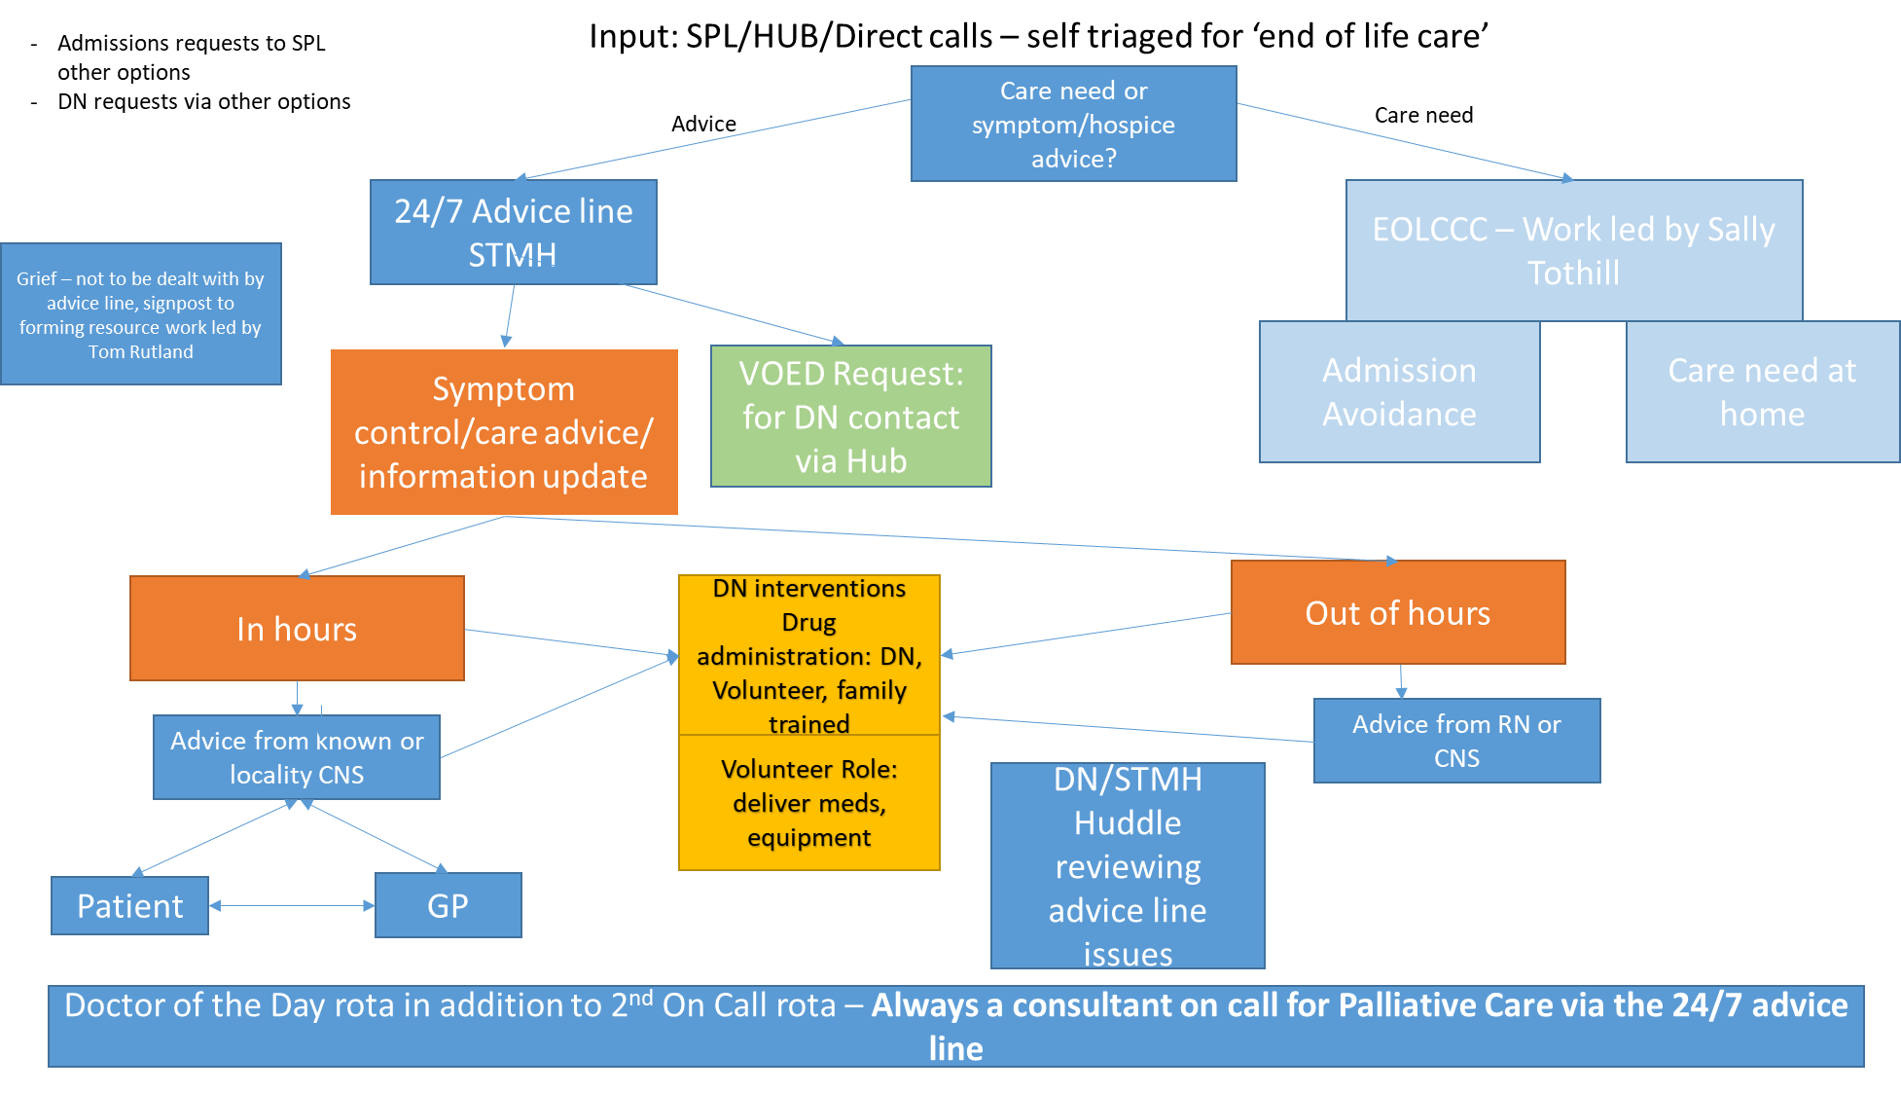

# Voluntary and Community Sector – Option 5

**Voluntary and Community Sector in Intermediate Care: The Community SPOC (Single Point of Access)**

**Aim:** To utilise community capacity and resilience to enable people to live well and stay as independent as possible in their own homes and communities. To provide a single point of reference to receive, allocate and track all referrals to provide a joined up triage, providing the best solution to support all discharge and divergence within the system wide intermediate care model in Somerset.

The service area will enable one reporting tool based on similar KPIS to be visible by the system to understand and articulate the demand, the solutions on offer and the outcomes of each solution against the current capacity.

 The single point of access will be used by the following organisations:

* Somerset FT: MPH, Community hospitals, Neighbourhood teams, District Nursing
* YDH
* RUH and WGH
* D2A, Rapid Response
* Bedded Pathways 2 and 3
* Primary Care

 The service area will enable one reporting tool to be visible by the system to articulate the demand and outcomes against the current capacity.

**Objectives:** This Single Point of Access to refer to the VCSE, will provide an opportunity for collaboration across health and social care in physical and mental health, communities and the voluntary sector. Through coproduction the group will ensure community and voluntary organisations are central to the Intermediate Care and divergence pathway by:

* Promoting independence for individuals within their own community
* Working in partnership to embed the model across the countywide system
* Highlighting gaps, opportunities through optimised resources and possible solutions for development
  + To enable targeted community development and support
  + To ensure there are community solutions to meet the needs of all individuals
* Agree and champion the model across all organisations to manage expectations and build understanding
* Make connections, sharing successes and learning

**Operating Arrangements for the Community Single Point of Contact (SPOC):**

|  |  |
| --- | --- |
| **Operating Hours** | 09:00hrs to 16:00hrs Monday to Friday.  Monday to Friday for referrals. Service provision will vary according to service required. |
| **Staff Professions involved** | Red Cross Coordinators  Community Agents  Administrators  Staff workforce of paid staff and volunteers including drivers to support transport |
| **Acceptance criteria** | * Safe to be at home * Suspected to have low level support needs that can be supported outside of or alongside, commissioned health and home care services * Supporting alongside D2A or Rapid Response or direct from acute or community hospitals and bedded pathways. * Supporting discharge for people who are privately funded and need help to navigate the care and support market-place. * Supporting home preparation prior to discharge |
| **Capacity** | Up to 15 referrals per day (based on previous benchmarking) – this will be reviewed and may change under the new arrangements |
| **Expected admission time frame** | Daily triage and same day response/ 48 hours, and within 2 hours for transport related referrals. |
| **Expected Length of Stay** | Average LoS up to 4 days. Will vary from one off contacts to up to 6 weeks + |
| **Onward Destinations** | * Discharged with no further support * Discharged with some wider voluntary sector support * Referred to ASC or escalation to bed provision |
| **Key Performance and Monitoring Indicators** | 1. Number of referrals by source and status 2. Number of discharges picked up within 2hrs, same day and 48hrs 3. Daily capacity to respond to requests 4. Length of stay 5. % discharged 6. % caseload 7. % referred / declined 8. % service breakdown of provision between providers |
| **KPI for providers:** | 100% daily Triage of referrals to the service  100% daily attendance on cluster calls, PDFs and acute links  % of referrals not appropriate  % referred to wider VCSE  90% positive client feedback / survey (survey arrangements will be universal and are under development) |

**Referral Process to VCSE**

There are 2 routes into the service. To refer into the pathway either via telephone or email as per the contact details below:

**Call 07734 908506** This will soon be replaced by a call to the Hub Option 5, and sit with all routes into Intermediate Care via the Hub. This process will be managed once full role out has been achieved and business as usual.

The following referral has been developed for referrals to the service. It is a live link and will be required for all referrals. This will replace individual referral forms previously used to refer into to the CCS and Red Cross for all services.

[**https://links.somerset.gov.uk/CommunitySPOCRequests**](https://eur01.safelinks.protection.outlook.com/?url=https%3A%2F%2Flinks.somerset.gov.uk%2FCommunitySPOCRequests&data=04%7C01%7CIBrimson%40somerset.gov.uk%7C0033c273311f44e592b308d89accb14c%7Cb524f606f77a4aa28da2fe70343b0cce%7C0%7C0%7C637429551227182979%7CUnknown%7CTWFpbGZsb3d8eyJWIjoiMC4wLjAwMDAiLCJQIjoiV2luMzIiLCJBTiI6Ik1haWwiLCJXVCI6Mn0%3D%7C1000&sdata=KMp3ynRJcfSPje3ddLTh4GuOCUbglUWz6IHQ5Ya61EA%3D&reserved=0)

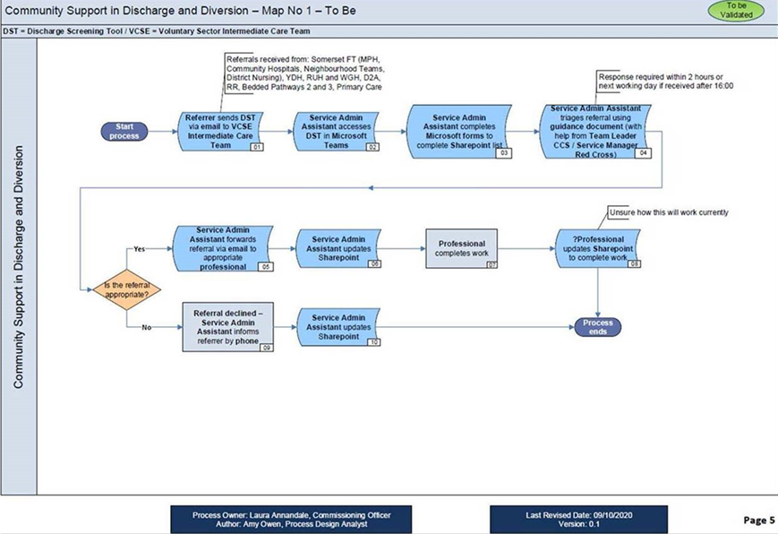**Reporting.**

There is a clear reporting tool that will allow the VCSE to report whole service outcomes in the form of a Power BI dashboard. The Dashboard will be refreshed daily and will show a clear breakdown of referrals into the service, the service response times, live case loads and Length of stay and outcomes. We will also better understand the support referred to and provided by the wider VCSE community.

# Adult Social Care Support across Intermediate Care

In response to the COVID-19 pandemic, the legislative and regulatory context for ASC has shifted in a variety of ways, including:

* Suspension of means testing of core care packages and placements.
* Suspension of Continuing Health Care with all care funded centrally.
* Introduction of DTOC measurements for intermediate care.
* New acute hospital discharge guidance.

The effect of these changes has been to increase emphasis on timely discharge from acute hospitals and reduce bureaucracy. ASC services have changed correspondingly with greater use of Trusted Assessment, interim placements, and short-term packages of care. Both the HIS team and ASC locality teams have adapted their roles accordingly:

### Health Interface Service

* **Acute hospitals** - In acute hospitals, the HIS team has continued to be part of the multi-disciplinary team making discharge decisions and facilitating discharge. The team works both in the discharge lounge and on the wards supporting socially complex discharge. Staff are responsible for Mental Capacity Assessments, Deprivation of Liberty Safeguards, and any Court of Protection cases.
* **Community hospitals** - HIS workers are also present in community hospitals, supporting socially complex discharges.
* **Pathway 2 and 3** - As pre-Covid-19, HIS ASC workers and social workers are assigned to specific Pathway 2 and 3 settings. From admission, HIS staff are part of multi-disciplinary (MDT) discharge planning, taking the lead on social issues. If a person is discharged from a Pathway 2 or 3 setting with homecare, the HIS worker will arrange a temporary package of care and facilitate the discharge process. After two weeks, the locality team will review the package and may conduct a Care Act Assessment. If a person requires a placement, the HIS worker conducts a Care Act Assessment and manages the discharge.
* **Interim placements** - As interim beds are primarily used for socially complex discharges, HIS staff in the acute discharge MDT should lead the discharge decision and process and continue to manage the case while the person is in an interim bed. Within 14 days, the worker conducts a review of the placement. As with Pathway 2 and Pathway 3, the HIS worker can arrange a short-term package of homecare if appropriate or conduct a Care Act Assessment and discharge to a long-term placement. If there are further actions to be completed before discharge from the interim placement (e.g. care not available, home adaption/specialist equipment needed) the worker updates AIS and schedules transfer of the case to the locality team.
* **D2A** - The HIS team will be part of the multi-disciplinary decision to discharge to D2A but, unlike with Pathway 1 pre-Covid-19, plays no further role in D2A and reablement.

### ASC Locality teams

* **D2A** – if the key worker thinks a person requires core care following D2A and/or reablement care, they can make a referral to the relevant Locality team. The team contacts them within 24 hours for a strengths-based conversation and, if agreement is reached a care package is needed, sends a referral to Sourcing Care. The team then review the care package after 2 weeks and may conduct a Care Act Assessment if long-term support is required.
* **Rapid Response** – the above process is also followed for Rapid Response.
* **Pathways 2 and 3** – following discharge from Pathway 2 and 3 with a short-term care package is arranged by the HIS team, the locality team conducts a review after two weeks. They may then conduct a Care Act Assessment.
* **Interim placements** – the HIS team is responsible for the initial review of interim placements after 14 days. In the event of discharge to homecare, the case is transferred to the locality team and reviewed after a further 14 days. In the event of discharge to a permanent placement or the temporary continuation of the interim placement, the case is transferred to the locality team with a review scheduled for 28 days.

The creation of Urgent Neighbourhood Response teams has enabled much greater integration of these community services with Locality teams.

During high levels of demand, the principles of the Ethical Framework and Mental Capacity Act must be adhered. No changes have been made to the Mental Capacity Act. Changes to the Care Act can be made if there is a decision to decide to implement Care Act easements, but this would have no impact on Mental Capacity assessments. Consideration to consent and Mental Capacity should be maintained at all times.

#### Adult Social Care: Overview of operating practice

|  |  |
| --- | --- |
| **Operating Hours** | HIS team: 8:00-18:00, 7 days a week  Locality teams: 8:00-18:00, Monday to Friday |
| **Staff requirements** | Social worker  ASC worker  Occupational Therapy support |
| **Acceptance criteria** | Accepts referrals from:   * Option 1 – Urgent Neighbourhood Response teams * Option 2 – D2A * Option 3 – all bedded care options |
| **Capacity** | n/a |
| **Expected admission time frame** | Short-term homecare packages from D2A and Rapid Response should start within 48hrs of referral |
| **KPI** | 1. Home care packages requested by source 2. Home care packages started by source 3. Number of people waiting for a home care package by source 4. Time from request to sourcing of home care packages 5. % of review and full assessments undertaken within 2 weeks of temp core care starting 6. Outcome of reviews 7. Placements requested by source 8. Placements started by source 9. Number of people waiting for placement by source 10. Time from request to sourcing of placements |

**Diagram 15: Post-Covid-19 ASC Services**

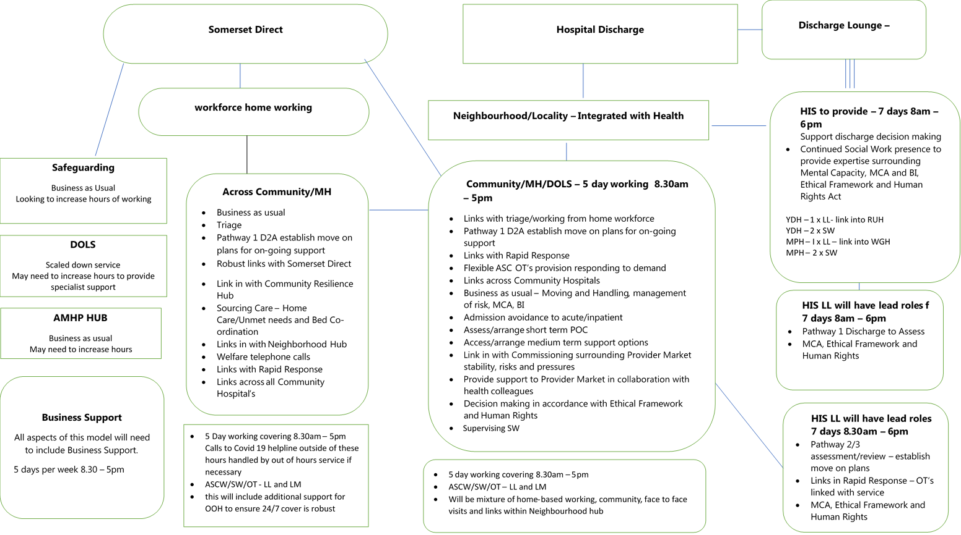

# Governance and Reporting

# 

# 

## System reporting and monitoring

The aims of system reporting and monitoring is:

* To ensure a shared, evidence-based understanding of system performance.
* To enable quick identification of emerging issues and to measure effectiveness of the response to them.
* To provide an overview of capacity to support resource and staffing decisions.
* To trigger escalation procedures where necessary to respond to surges in demand, especially Covid-19 cases.

Monitoring is supported by a performance dashboard, comprising of high-level metrics from relevant system components:

* Acute hospitals – from A&E to supported discharge
* Somerset Hub for Co-ordinating Care
* Rapid Response
* D2A and reablement
* Bedded care
* End of Life
* Adult Social Care
* Care homes

Metrics provide insight into both patient flow through the system and the performance of elements of system. Data is provided by the relevant service areas. The dashboard is produced twice weekly by the CCG’s Commissioning Support Unit and is shared with the Operational Group and the Programme Board.

The frequency of production of the dashboard is currently under consideration. Further work is needed to define the performance targets and thresholds of each metric, resulting in a complete set of KPIs. Work is in progress to improve the quality of data and the consistency of data sharing, and to fill data gaps.

## 8.2 Governance

To be updated by Tracy and Tim

## 8.3 Escalation Policies

To be developed for each service by working group led by Lynn Stephens

# Appendices

# 

## 9.1 Intermediate Care Model- Formal Complaints Pathway

**Diagram 16: Formal Complaints Pathway**

Complaint received and logged.

If hospital stay or discharge related follow normal PALS procedure. If Care provider or pathway related then via LA complaints process

Relevant complaints team allocates the complaint to an Investigating Officer and copies-in the relevant Line Manager.

**I**

**N**

**V**

**E**

**S**

**T**

**I**

**G**

**A**

**T**

**I**

**O**

**N**

Investigating Officer reviews case notes and conducts interviews with staff involved if appropriate.

Investigating Officer monitors progress of investigation and informs Pals or Social Care complaints if there is a possibility of

a missed deadline.

Investigating Officer sends draft response and action plan to appropriate person (depending on whether bedded or non-bedded pathway) for quality assurance check.

Once approved, final draft response and action plan is sent to Complaints Manager for final check and transmission, copying-in all relevant parties.

Draft response is quality assurance checked/changed and is passed to [*INSERT appropriate person in organisation*] for approval.

## 9.2 Covid-19 related Policy

#### Infection Prevention and Control Precautions for Discharge of Covid-19 Inpatients



## 9.3 Guidance for the Use of Interim Beds

**Why would someone need an interim placement?**

In some circumstances it may be appropriate for a person to be placed in an interim placement. Often it is because there are temporary social issues that are preventing them from returning home and the person needs a safe place to live whilst these issues are being solved by Social Services. In these cases it is not appropriate for the person to wait in an acute bed, a community hospital bed or in a pathway bed.

However, these interim placements should be the last resort for a person when all other options to get them home have been exhausted.

**Interim placements should be used with caution due to the following factors:**

* Interims take people away from their home, away from family and friends and all that is familiar to them.
* People decondition when in placements,
* In the current climate they may be at heightened risk of infection

**Decision makers must take into account:**

* The person’s mental capacity
* The person’s ownership rights over their home.
* That multiple moves are not in a person’s best interest
* That it can be more difficult to transfer someone out of an interim placement than it would have been direct from the hospital
* That a hospital episode is also not an appropriate time to address issues that were outstanding prior to admission, and which the person has lived with for a significant length of time. For example an amount of hoarding that the person has managed for years is not a reason to prevent someone returning home, if that person has capacity and chooses to live that way.

**Below are some examples of when an interim bed may be suitable:**

|  |  |
| --- | --- |
| Carer Breakdown | A carer who shares ownership of the property or if not, someone who has a right to reside in property and offers a substantial amount of care to the person feels unable to continue to offer this care. |
| Domestic abuse / safeguarding issues | Concerns that the person may be physically or mentally at risk from a third party if they return home. |
| Home environment | Home is no longer suitable due to new medical needs; for example person has had a stroke and requires equipment that their home cannot accommodate. |
| Awaiting something to happen prior to returning home and this cannot be brought forward. | Person who is awaiting essential equipment to return home.  A person awaiting extra care housing. |

1. Acute Hospitals can refer directly to Urgent District Nursing without going through Option 1 in the hub.