Micro-providers in Somerset: A Strategic Review
Somerset Council have been supporting the growth and development of small, independent care and support services (Micro-providers) since 2014. In Autumn 2022 the Enterprise Development Team conducted a 4-month multi-stakeholder review, seeking views from the following around their experience of being, using, referring, or working with Micro-providers:
- 508 Direct Payment and commissioned home care recipients
- 221 Micro-providers
- 96 Social Workers, Occupational Therapists, Village Agents, Social Prescribers, Direct Payment Advisors
- 15 Domiciliary Care Agencies
The results have informed this report and proposed future strategy. For further details of the data/ results and workings of the report see (Micro-provider Raw Data).
What’s working well for people and the Somerset health and care system.
- Care Capacity: Micro-providers bring additional capacity to the care at home marketplace.
  - 1,170 (811 verified) new Micro-providers in Somerset delivering 31,122 hours support to 5,903 people in Somerset.
  - 2,141 enquiries to become a micro-provider (Jan 2020- March 2023) 82% of enquiries are additional capacity driven by people joining / returning to care at home marketplace. *18% of enquiries from Domiciliary Care workers.
- Personalisation Choice and Control: Greater variety of local supports means more people are choosing to self-direct their care.
  - 119% increase in Direct Payment uptake (2018-2022) establishing Somerset as a national leader around self-directed support (ranked 17th out of 150 local authorities).

  - 70.3% of Direct Payment recipients surveyed used a Micro-provider with their personal budget.
  - 91% of Social Workers/ social prescribers said “people opting for a personalised care service” as the principal reason to signposting to Micro-providers.

- Targeted Prevention. People are getting help earlier from Micro-providers, delaying or avoiding the need for formal or statutory health or care services.
  - 73.3% of the support Micro-providers deliver is to people who self-fund their care.
  - 59.3% % of the support provided by Micro-provides is non-personal care. A majority of support is preventative lower level domestic, welfare, social and community support, facilitating registered services to use capacity to support complex / personal care services.
  - Micro-providers have led the formation of neighbourhood care collectives inc. volunteering and good neighbour groups e.g., Wivey Cares, Wincanton Cares
- Quality: Personalised services offer improved outcomes for the people they support
  - Micro-providers performed higher across all outcome measures in a comparative study of 508 direct payment (141) and commissioned (367) individuals. See: Homecare Outcome Survey 2022.
  - Rediscovering a Good Life -How Jane found her Jam – Story from Somerset’s successful 2021 “Delivering Better Outcomes” MJ award submission.
  - Live micro-provider customer feedback loop (MP Customer Feedback Sep22-Apr23)
  - Direct Payment Survey: Customer feedback strong themes of time, trust, relationships, and continuity of care. Direct Payment Customer Survey
  - 76% of Micro-providers felt the best thing about being a Micro-provider is delivering personalised care – 2022 Survey Results
- Economic Benefit: Meaningful self-employment and £3.7 million annual savings to Somerset Council
  - Survey results showed 74% of direct payment recipients use Micro-providers. If this 74% of people used commissioned home care this would cost Somerset Council an additional £3,704,844 per annum (based on 22/23 rates)
  - Keeps money local and supports entrepreneurialism and employment in rural areas of Somerset
- Workforce: Attractive offer to people joining or returning to social care
  - 85% of enquiries through word of mouth.
  - The average age of a Micro-provider is 45. Attracting experienced people looking for a flexible work option.
  - 439 (32%) enquiries from people coming back into social care
  - At an average of £17 p/h Micro-providing offers attractive pay/flexibility- work life balance
  - 26% would leave social care if Micro-providing was not an option.
  - 65% would be open to employed roles alongside Micro-providing, offering a hybrid working model that aligns with wider workforce trends and Proud to Care.
- Hospital Discharge: Micro-providers core to VCFSE response directly supporting over 1000 people out of Somerset’s acute’s in 2022.
  - For every 5 people leaving hospital through intermediate care home first pathway there are 2 people are supported via the VCFSE pathway to leave hospital with Micro-provider support.

  - Market Resilience & Development: Disruption driven better pay and conditions in registered services. Micro-providers have encouraged new entrants to the market with Atwell Care, Dementia Care TLC, Redleif Care, Silverstars Homecare, You are my sunshine have developed through the Micro-provider pathway.

  - The growth of Micro-providers and the workforce disruption has forced changes in employment terms, recruitment and retention.
“In Summer 2021 we had to seriously consider closing the business due to recruitment challenges. The development of Micro-providers had made harder to keep staff and find new ones. We changed our business model completely. We moved from zero hours to a 40hr a week contract for workers, offering salaries of £23/ £24k. We now have no issues with recruitment and retention and no longer feel the presence of Micro-providers a threat. By working with complex, domiciliary, and live in care roles we can give staff opportunities to develop, learn and stay fresh. It has moved people from being a job to being a career”.
Domiciliary Care Provider

What’s not working for people and the health and care system.
Information and Education
People and professionals lack the knowledge to refer to and use Micro-providers safely and appropriately with a clear understanding of the legal and regulatory boundaries they operate within.
  - 54% of Social Workers surveyed use Micro-providers primarily for multiple visit personal care compared to 11% of other social care professionals.
  - 44% of social care professionals surveyed thought Micro-providers were able to co-ordinate or create rotas of care.
  - 53% of social care professionals surveyed cited ‘Lack of CQC registered services’ as a key factor in referring to Micro-providers.
  - 55% social care professionals are neutral or not confident in the legal and regulatory boundaries that Micro-providers operate.
  - 53% of domiciliary care providers are “extremely not confident” in the legal and regulatory basis that Micro-providers operate.
This data strongly indicates a care system that is using Micro-providers as a replacement for Domiciliary Care services. There is growing evidence that Micro-providers are being used or signposted to people who lack capacity to self-direct their care or have not received appropriate information relating to the risks and responsibilities that come with using unregulated care provision.
There have been cases presented to Enhanced Peer Forum where professionals were seeking to use Micro-providers as a replacement for registered services for people with complex care needs where these were proving difficult to source, under what appeared to be the false assumption that Micro-providers have the legal ability to manage and direct care and arrange cover for sickness. The safe and appropriate use of Micro-providers relies on the Micro-provider, the person receiving care or their legal representative and any health & social care professional having a clear understanding of and working within these legal boundaries.

Accreditation
Somerset Council’s Micro-provider verification process gives false assurance to families and social care professionals in Somerset.
Somerset Council currently require registered providers to provide supporting documents (Public Liability Insurance, Enhanced DBS, Contract, Complaints Procedure, Support Plan) to achieve verified status. The verification process has no legal or regulatory function. Verification does not seek evidence of training, qualification, references or right to work.
The risks and responsibilities for interviewing and assessing the suitability of a provider, and overseeing the quality of care delivered, lie solely with the person using the service or their legal representative. Most people engaging with Micro-providers are not fully aware of this responsibility. 50% of social care professionals surveyed believed that Somerset Council ‘regulate’ Micro-providers. This leaves a confusing situation for families and professionals and increases the risk of people uncritically using the services of unregistered care providers.
Infrastructure
The scale of growth of Micro-providers has outpaced resources required to provide adequate information, support, and oversight.
  - 790 people enquired to become a micro-provider in 2022. With 250 enquiries (Jan-March 23) it is projected this will be over 1000 enquiries in 2023 (35% conversion rate). Co-designing standards, expectations, and a nurturing a culture of quality at this scale is a challenge.
  - At least 345 Micro- providers operate ‘off scheme’. This number is unknown but increasing. In a survey 19% of Micro-providers accessed their work through Somerset Council routes, limiting Somersets Council ability to influence the marketplace.
  - With over 5,903 people being supported by Micro-providers in Somerset we have not found a way to operate:
    - A clear customer feedback loop to share positive outcomes but also identify quality or safeguarding concerns.
    - Accessible and engaging ‘using micro-providers’ guides for information to people, families, communities, and professionals.
    - Training to health and social care professionals around self-directed support, direct payments, and Micro-providers.

Market Disruption
Micro-providers are disrupting the sustainability of traditional domiciliary care services in Somerset.
  - 4,276 (72.3%) of the people Micro-providers are supporting are self-funders. 59.3% is lower-level support. This has taken a large percentage of the most profitable support from registered care services. Registered providers report having to accept more local authority packages at a lower rate. This work is usually more complex in nature meaning that the role is more demanding, creating knock on effects in registered services ability to recruit and retain a stable, committed workforce.
  - 244 (18%) of enquires to the programme were from Domiciliary Care workers in 2020-2023. Whilst 54% suggested they would have left social care or moved roles if Micro-providing was not an option 44% would have stayed. Based on a 35% enquiry to Micro-provider conversion rate this is 85 people leaving domiciliary care services to become a Micro-provider in Somerset, increasing the workforce challenge for the sector.
Continuity & Contingency
Micro-providers that choose not to work weekends create difficulty sourcing care for people requiring a 7-day service.
  - 80% of social care professionals agreed (29%) or strongly agreed (51%) that Micro-providers not working weekends limits their use and value to the care system.
  - When asked to rank what is needed to improve Micro-provision in Somerset “Micro-providers offering a 7-day service ranked highest out of 10 options

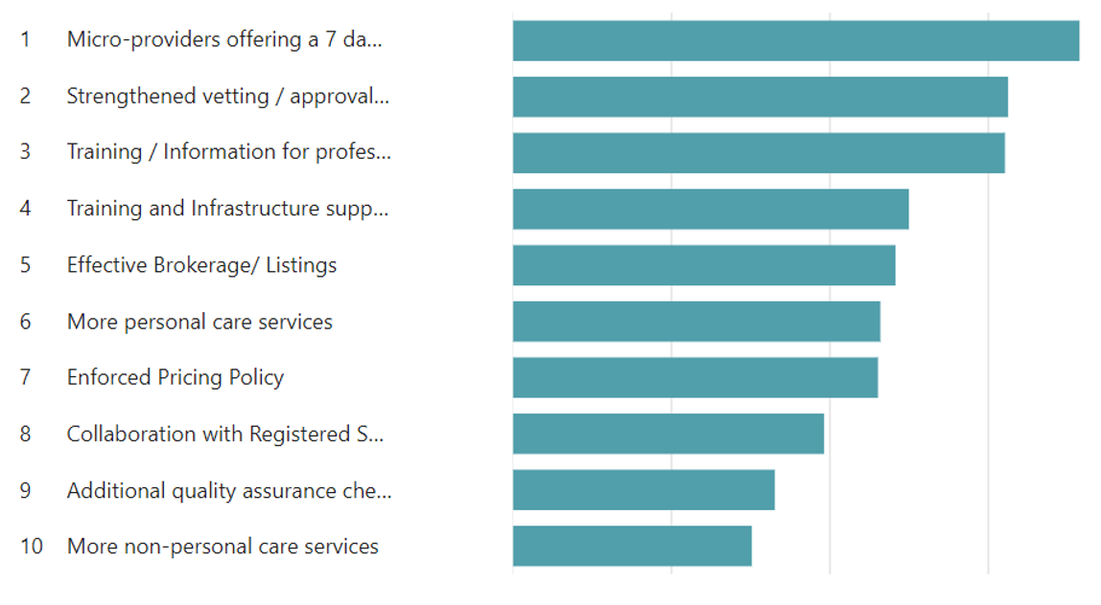

Micro-providers similarly responded that their biggest challenges are finding cover / contingencies. For a further responses on these challenges see: Micro- Challenges Sep 22
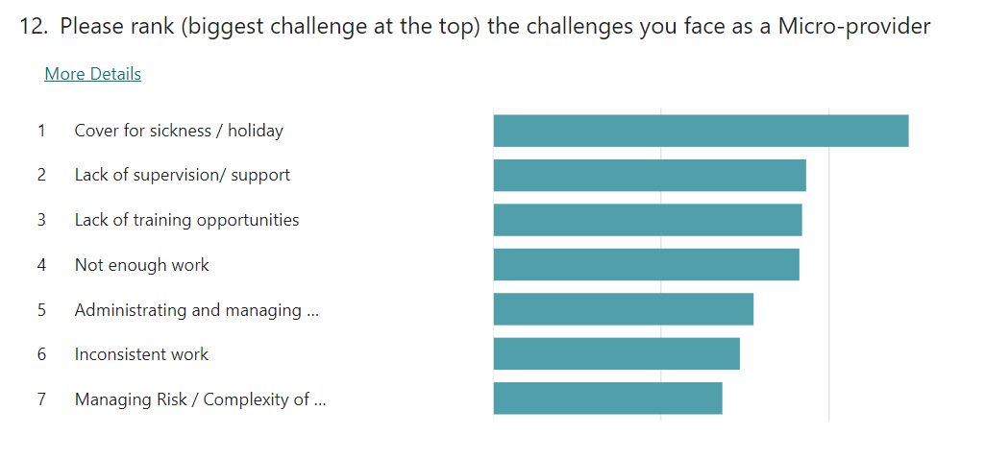

The Future: Developing Micro-providers - 2023 Strategic Priorities
In order to address the challenges outlined above the Enterprise Development Team have highlighted four key development priorities with the following proposed actions.

- Embed a reformed quality standard and governance process that has been agreed with ASC’s quality assurance team.
This involves
  - Design and delivery of Micro-provider application/ renewal process that removes the requirements for Somerset Council to upload and check documentation but has an emphasis on ‘knowledge’ of the legal / regulatory boundaries that Micro-providers operate within. This will also include Somerset Council ceasing to issue ID badges with immediate effect.
Outcomes:
  - Micro-providers feel involved, engaged, valued.
  - Micro-providers required to actively engage with and evidence regulatory/ best practice knowledge to become registered or annually renew registration.
  - Is enforceable by the quality assurance team.
  - Provides assurance to Somerset Council but makes clear to the public that it is the customers responsibility to interview, vet and direct the work of the Micro-provider.
  - Is clear/ understandable by families and professionals.
  - Re-sets relationship between Somerset Council and Micro-providers
  - Offers dynamic guidance, information, and education to Micro-providers in Somerset.

- Educate and inform people, communities and the health and care system around the safe and appropriate use of Micro-providers.
Outcomes

  - Micro-providers only used by people and families that are able and willing to ‘self-direct’ their care and support.
  - People/ professionals will know the risks and responsibilities of using unregistered care providers.
  - People / professionals will know the boundaries, best practice and expectations when using unregistered care providers.
  - People/ professionals will have a recognised and promoted route to feed back their experience of using Micro-providers.

- Build processes to increase the number of Micro-providers who work with, alongside or for CQC registered services in Somerset.
Outcomes:
  - Increased opportunities for people to have more choice regarding how their outcomes are met that could include a mixture of both regulated and unregulated care and support.
  - Attractive hybrid or flexible working opportunities for people to work across the health and care system.
  - Aligns with workforce trends.
  - Micro-providers access training, supervision and CPD opportunities.
  - Increased capacity for registered services. Flexible staffing at times of surge or pressures.

