Somerset Independent Living Centre (SILC) Highlight Report

Business and Performance Information | Reporting Period | Commissioning Lead
 | 1 December 2023 – 30 January 2024  QPRM submissions from the Wellington, Yeovil and Shepton ILCs enclosed | Nigel Pluckrose & Jules Bellew
Operational Performance and Outcomes | Demand for SILC appointments continues to grow, with the expected slight dip in demand during the December period. The graph below shows demand from March 2023 with on-going upward trend.  Ask Sara topic reports for 2023 indicate the most requested topics which continue to be showing and bathing. There continues to be an increase in Ask Sara ‘hits’, with the majority of referrals being directed from www.somerset.gov.uk/equipment  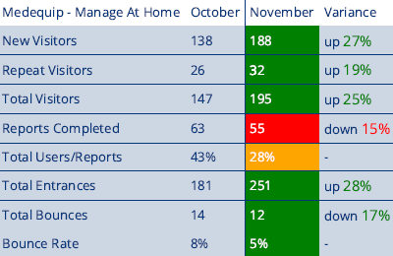  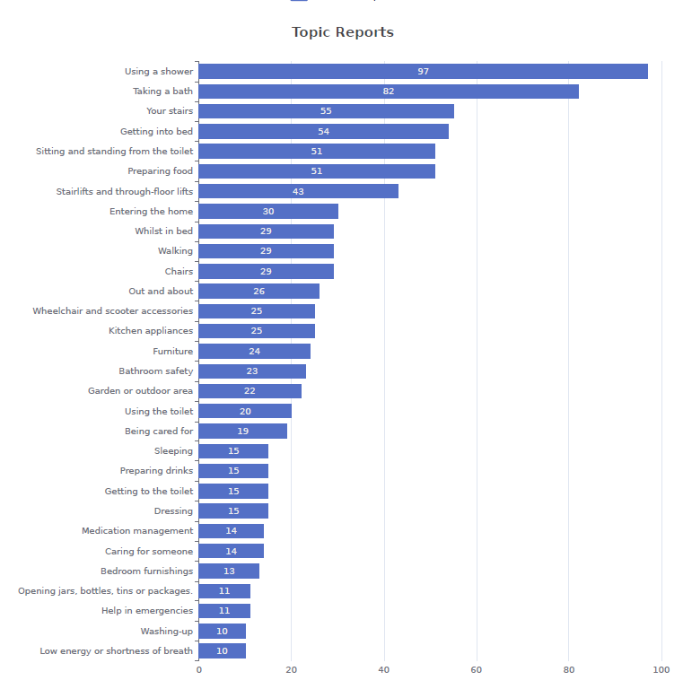  Areas of good practice  Yeovil - Feedback demonstrating a person-centred service offering relevant and appropriate advice and information.  Shepton - Large amount of high-quality statutory assessments being completed by the team, primarily in SILC, but also at home – primarily housing options assessments at home, but some general assessments also for people who really can’t attend the centre  Wellington - high number of these housing assessment referrals and will be allocating a specific day for Housing. Rural outreach well received in the Dulverton community and now manned by a permanent OT, currently on a weekly basis.  Approximate waiting time for appointments (weeks): Shepton 2/3, Wellington 4/5, 3/4. Demand for Wellington due to number appointments also from Sedgemoor area where no SILC Service currently exists.  Some non-attendance despite reminder calls the day before. There has been poor weather floods/ice/wind which contribute to people cancelling / rebooking.  Customer feedback for the service continues to be very good with 93 feedback forms completed for the period with customers rating the service 4.83 out of 5 (80 people scoring 5 out of 5).  “The visit to SILC was wonderful so helpful and informative. The help and knowledge was so nicely presented to me. Care and consideration to my personal needs was so kindly shown cannot say thank u enough..”  “Very professional, good examples of care, very approachable, great experience”  Areas for development  Requirement for risk assessments around bed levers and other bed equipment has meant a considerable increase in the time assessment paperwork is taking.  Ongoing problems with the SILC outlook calendar, this has been escalated to ICT to fix immediate problem and consider future alternative.  The Adult Social Care TEC offer will be available in all SILCs, allowing staff to demonstrate all items on the catalogue and prescribe directly where appropriate. This will be supported with appropriate training from Claire Collett, TEC OT.  The financial emergency has impacted the property element of the SILC Service. The 1st floor of the Shepton SILC building is currently closed to staff and the heating at Yeovil SILC has been reduced impacting staff and customers – this is being addressed.  Workforce: Positive reports of good morale in all SILC Teams. There are no significant staffing issues. Over the winter period there was some sickness as expected, but teams were able to continue to deliver a high-quality service with managed disruption. Training completed includes deafblind, Oliver McGowan and first aid. Further detail available on the individual SILC QPRMs.  Appointment data  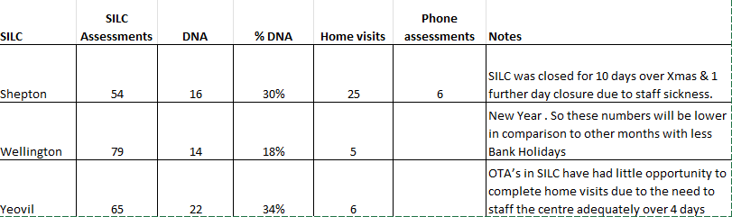  Heat map below indicated where individuals are travelling from for their appointments  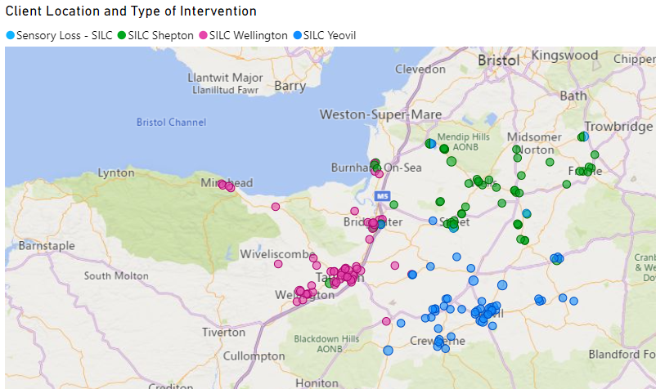  Reasons for visiting the SILCs  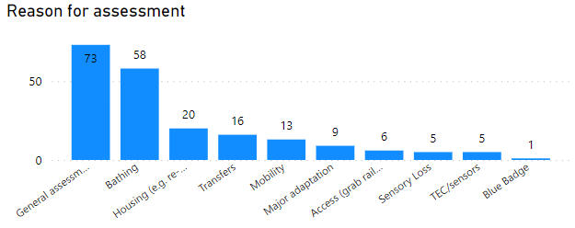  Outcomes:-  Delay/prevention of Home Care Hours:  - SILC intervention was projected to delay the need for/an increase in home care services in 16% of attendees the period Dec23-Jan24  - Projected home care hours delayed in period Dec23 – Jan24 (per week): 168 Hours  - Cost of projected home care hours delayed per week : £3722  Follow up required:-  Only 12% of clients required a follow up home visit, this would include those needing major adaptations.  Prevention: -  A visit to a SILC during Dec23- Jan24 was asssessed as preventing:  72 visits to A&E/Minor injurues  49 preventions of Informal carer breakdown  42 people having go move home  Both Detailed QPRM’s for Shepton, Wellington and Yeovil are listed below:-

RAG Status and Trend |  |  | Reason for Red / Amber
Previous Period | Current Period | Forecasted direction
 |  | ⇨ | Both ILC’s are still developing their specific service offer and should be aligned to the ASC OT restructure implementation phase 1.

Milestone | Date | RAG
The opening of the Somerset Academy is delayed due to the sensitivity of the site (listed Building) - awaiting ASC involvement into the project. | June 2024
The Appointment of SILC staff is ongoing but is gaining momentum and new interest. Most OT & OTA Posts could be filled in the next quarter. | May 2024
To confirm the possible Taunton ILC, offer versus Wellington | June 2024
To secure the ongoing funding for the SILC Model | June 2024
To investigate the Bridgwater Library as a distinct ILC interim measure for 2024/25 | June 2024

Key progress over this quarter
- The booking process had improved but still needs to be reviewed due to calendar issues
- The Data reporting has been inconsistent to populate the monthly QPRMs, due to a lack of technical resources, but is now supported by a summary quarterly reporting
- The SILC sessions offered are increasing and supporting the neighbourhood waiting list reduction
- Continue to receive lots of positive feedback from visitors to the Centres
- The TEC offer is starting to unfold with all the SILCs

Focus for the next quarter
- To consolidate the funding stream for the SILCs going (via the ‘Better Care Fund’) as part of the newly forming slimline/leaner Council.
- To review the Sensory Loss, offer and staffing as part of the TEC developments.
- Developing the preventative offer, aligned to Brave AI, the ARF Bid and Neighbourhoods
- To review progress made with the ILC Health OT Practitioner offer P

Risks and Issues - Include all New, Red or Deteriorating
R/I | Description | Impact | Action / Mitigation | Owner | RAG
Risk | To ensure that the corporate property portfolio and financial decisions align with the future Taunton and Bridgwater ILC needs (The West Side) | It will destabilise the evolving OT Service and prevention focus across the County; and for the future. | The ILC OT in Wellington is now starting to progress and align its Service offer with Shepton and Yeovil. | Nigel Pluckrose

