Somerset Safeguarding Adults Board  Performance and Quality Sub Group  8th February 2024 | 
Market shaping and Stability in the Somerset Care Market
Author: James Cawley, Strategic Commissioning Manager
Organisation: Somerset Council, Adult Social Care
Contact Details: james.cawley@somerset.gov.uk

1. | Summary
1.1 | This report seeks to provide the Performance and Quality subgroup with an overview of how Somerset Council works to ensure the adult care market is sustainable and able to meet the diverse needs of the county. It is submitted at the specific and direct request of the Safeguarding Adults Board.
2. | Issues for consideration / recommendations
2.1 | For members of the SSAB / Performance & Quality subgroup to note the information provided within the report and its supporting appendices, and test assurance in relation to the following elements captured within the SSAB’s strategic plan:
2.2 | - Ensure the care market is robust and able to meet the diverse care and support needs our clients require to fulfil engaging lives;  - Seek assurance from commissioners that they have robust mechanisms to address market fragility;  - Ensure commissioners can identify providers within the appropriate offer for clients’ needs within the cost envelope. Levels of unmet need and contract handbacks are reduced.
3. | Background and detail
3.1 | Strategy: Adult Social Care’s overarching approach is set out in Adult Social Care Strategy 2023 – 2026. It sets out how we will work to deliver our vision in partnership to ensure we deliver the right kind of care and support for our communities, and the best possible outcomes within the resources available to us.
3.2 | There is a clear ‘golden thread’ across key strategies in Somerset, demonstrating shared commitment to:  - Improving people’s health and wellbeing.  - Focusing on prevention and early intervention.  - Investing in our communities and neighbourhoods.  - Promoting people’s independence whilst ensuring easy access to high quality support when required.  - Reducing inequalities and improving outcomes for those with more complex needs.  - Supporting the wider health and care workforce.
3.3 | Market Position Statement: Adult social Care has a duty to develop and publish a Market Position Statement (MPS). Adult Social Care were proposing to publish a new MPS in the autumn of 2023. However due the Council’s financial position a decision was taken to defer publication until February 2024, after the Council’s 2024/25 budget had been agreed. Attached as Appendix 1 is the draft MPS (2023-26); this has not yet been published and is subject to revision.
3.4 | The purpose of a Market Position Statement (MPS) is to outline what services are delivered within a local authority area and to signal to the care market further development opportunities for care and support services. They were introduced as part of Local Authority market shaping duties under The Care Act 2014 and are a starting point for market engagement and facilitation.
3.5 | Our MPS sets out:  - How we see Somerset changing, our ambitions in responding to that change, and what changes mean for people relying on local care and support services as well as for our care market;  - What services and support are available, any gaps, and how services should be delivered, to help both current and prospective providers;  - Our commissioning intentions to support and guide local care providers to shape and develop their services to meet local need and demand, setting out future needs and opportunities for providers.
3.6 | Key principles with the Council’s Market Position Statement are:  - The care and support needs of people and communities are understood.  - There is a varied and resilient provider market with sufficient capacity to meet demand now and into the future.  - Local people, including those who fund or arrange their own care, have access to a diverse range of safe, effective, high quality support options to meet their care and support needs.  - Services are sustainable, affordable and provide continuity for people.  - We actively work towards integrating care and support services with those provided by partner agencies to achieve better outcomes for people who need care and support and unpaid carers and to reduce inequalities.  - Partnership working helps ensure that care and support meets the diverse needs of individuals and communities.  - People experience seamless care and support journeys, and their support is well coordinated across different agencies and services.
3.7 | Within the Market Position Statement, the key strategic messages for care and support providers are:  - We want to help people to live a good life, remaining well and independent for as long as possible.  - We want to shape local services to be more outcome-focused, enabling people to have greater choice and control and supporting them to achieve their goals.  - Co-production and engagement with service users and communities as commissioners and service providers is critical to service improvement and development, and to ensuring high quality provision. Somerset Council recognise there needs to be a significant improvement in our approach to working together as equal partners – listening, respecting and valuing all opinions.  - We expect to see demand for social care support to continue to increase against a backdrop of an increasingly aging population, driving huge additional demand for care at home services. Despite having a large and diverse market we are still reliant on a small number of providers for half of the support delivered.  - The evidence is clear that ‘home’ is the most appropriate place for resolving crises and recovery for adults and older people being discharged from hospital. This care and support must be personalised to enable people to live in dignity and stay in control. Wherever possible, people leaving hospital will be supported to recover at home through the provision of short-term reablement or rehabilitation, be assessed for any ongoing care needs from home, and be supported to avoid a hospital admission from home. We will look to extend best practice and reorientate services and funding to help more people get home when that is the most appropriate place for them – and to stay at home.  - We require providers who are able to meet the changing needs of our population, supporting more remote areas of our county where care is harder to source, and individuals for whom provision is more difficult to secure or where there are limited alternatives to residential care.  - A priority for us is to develop appropriate services in people’s homes and increase the amount of care homes with dementia provision in Somerset if we are to be able to effectively respond to the demographic changes anticipated. Rates of dementia in Somerset are significantly higher than the national average due to our demographics and there are indications that even this may significantly under-estimate the true picture.  - We wish to work with innovative developers, housing providers and providers of social care services that have experience and knowledge of the specialised housing sector to develop a range of accommodation and services.  - We want to see the development of vibrant, new Extra care schemes that meet the needs of local people and have a community presence.  - The Council will also continue to monitor the cost of care and seek to pay a fair price through transparent commissioning and contract arrangements. Somerset Council’s Medium Term Financial Strategy outlines the key financial issues, the proposed response to these financial challenges, and our plans for spending. As part of the strategy, service commissioners will continue to work with stakeholders to achieve significant savings through service transformation and re-design; contract re-negotiation with existing providers; and decommissioning or reinvestment in more effective and efficient services for improved outcomes for local people.  - The sustainability of the market will only be achieved if we continue to develop and deliver our joint Health and Social care strategy. At the heart of this is working in local neighbourhoods, linked to communities and the places people live, enhancing our digital offer, housing and joint commissioning arrangements.  - Somerset Council is required to consider how the economic, social and environmental well-being of the county may be improved through the procurement of the services or goods before commencing a procurement process (as part of the Public Services Social Value Act 2012). The aim of the Act is to ensure that as part of the commissioning and procurement processes, consideration is given to the wider impact of the delivery of the services and goods. It allows a council to consider as part of the tender process how suppliers go beyond the basic contract terms and secures wider benefits for the community.  - It is important for providers to identify and incorporate digital solutions alongside all service areas where possible and appropriate. This includes assistive technology services, but also wider digital innovation within provision.  - Throughout all this, a key priority will be to continue to work across health and social care with provider organisations to support and develop our workforce and drive wider care quality improvement
3.8 | Market Sustainability (Over 65/Older People’s Care Market): In May 2023 the Council published a Market Sustainability Plan for the older people care and support market, which was developed following the Government request to understand the fair cost of care in Somerset. The MPS is informed by the findings of the Market Sustainability Plan.
3.9 | The Market Sustainability Plan highlighted the Council’s ambition to meet the fair costs of care by 2025. This ambition was proposed prior to the Council’s corporate financial emergency situation. Work is ongoing to review the findings of the Market Sustainability Plan in light of the Council’s financial position
3.10 | Home care sufficiency: During 2023/24 Adult Social Care have completed a procurement process to award a number of home / domiciliary care block contracts. This involved a competitive procurement process to secure the supply of quality care and support at home services. This approach is designed to help develop a market that delivers a wide range of sustainable high-quality care and support services in difficult to source or high demand areas, and will offer guaranteed hours under 6 lots for the following areas:  - Lot 1 – Glastonbury and Street, 150 hours  - Lot 2 – Shepton Mallet and Wells, 200 hours  - Lot 3 – Frome, 100 hours  - Lot 4 – Yeovil, 150 hours  - Lot 5 – Bridgwater, 200 hours  - Lot 6 – Minehead, 200 hours  The Executive report covering this procurement project is in the public domain
3.11 | This service, to be implemented from April 2024 will deliver better outcomes for people, enabling them to continue living at home for as long as it is safe to do so. This will contribute to the reduction of hospital admissions, delayed discharge or long-term care home placements and the costs associated with these.
3.12 | Somerset Council currently commissions around 19,000 hours of home care per week through Home Care providers, supporting around 1,400 adults. The gross cost of these services is approximately £26m per year (2023/24 prices). The current contracting arrangements for Care and Support at Home can be inefficient and does not encourage a collaborative approach to meeting needs at a local level. There are currently 49 active home care providers across the county but analysis reveals 50% of the delivery is from just 8 providers.
3.13 | The re-commissioning exercise has been undertaken to give an opportunity to improve the quality and robustness of the care and support at home services to ensure they are fit for the future. The Local Authority role is seen as critical and under Section 5 of the Care Act, the duty to shape and maintain an efficient and effective market of services for meeting care and support needs in the local area is firmly placed with Somerset Council. The re-commissioning plan included a review of current services with key stakeholders, partners, providers and customers to co-produce a service model that could respond to the following challenges:  - Demographic changes to an increasing elderly population  - Increased demand on the health and social care services that impact on hospital admissions and delays in discharges.  - Financial challenges regarding Fair Cost of Care and Cost of Living Crisis  - Recruitment and retention of workforce.
3.14 | A further process will be developed and implemented that will utilise a Dynamic  Purchasing System (DPS) to purchase care and support services with providers that have met the eligibility criteria to join. The DPS will be set up across 13 zones, which are broadly aligned with the county’s Primary Care Networks. This will enable Somerset Council to manage the market and joint working more effectively.
3.15 | Levels of unmet homecare need: Somerset has continued to see the impact of additional investment and focused commissioning activity, as well as some pick up in care provider recruitment of new starters including from overseas, with levels of unmet homecare need falling to their lowest ever levels since March 2021. We are presently in a position where provision of domiciliary care outstrips demand, meaning we are not currently accepting any new home care providers onto our procurement framework. This is a significantly improved position to where we were a year ago.  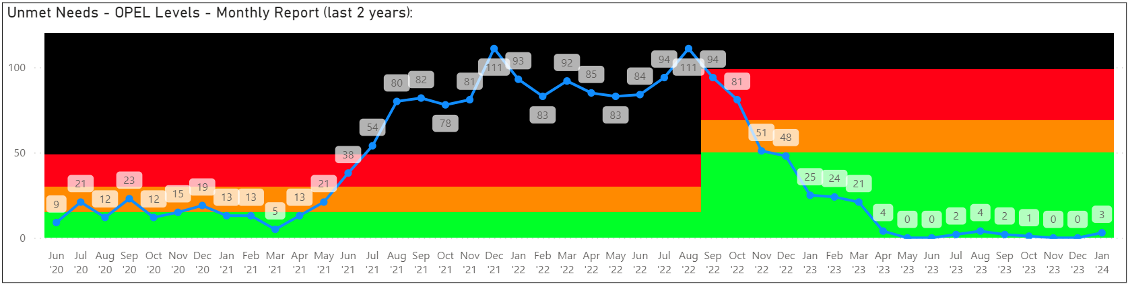
3.16 | Homecare Contract ‘handbacks’: Although occasional care package handbacks are not uncommon and can occur for a variety of reasons, most commonly provider staffing capacity issues, these rose sharply in Somerset during the pandemic as evidenced by annual stats below:  - 2021 – 233 package handbacks (average per month – 19.4)  - 2022 – 238 package handbacks (average per month – 19.8)  - 2023 – 157 package handbacks (average per month – 13.0)  Care package contract handbacks place additional pressure on Local Authority staff to find replacement care within a stretched care market and is an indicator we monitor closely as part of our commissioning and quality activity.
3.17 | Governance: Adult Social Care is currently developing a Commissioning framework that will bring together all of our commissioning strategies under three themes:  - Early Intervention and Prevention  - Long Term care and Support  - Specialist care and Support  Each theme will outline our specific commissioning strategies, equality impact assessments and actions plan. The framework and strategies will be reviewed through Adult Care Commissioning and Oversight Group. The redraft of the Market Position Statement will reflect the commissioning themes.
3.18 | Care market quality assurance: The Care Quality Commission (CQC) has the overarching role to monitor, inspect and regulate health and social care services to make sure those who use these services receive high-quality, safe, effective, and compassionate care. We work closely with the CQC as part of our routine system surveillance activity.
3.19 | Through our monitoring and assurance function, we support and work alongside our local care providers in obtaining the best possible standards of care, as well as holding them accountable for doing so, working closely with any provider that falls below a ‘Good’ overall rating as part of a quality improvement process  81.7% of Somerset’s active social care settings (residential and community provision combined) inspected by the CQC were rated as ‘Good’ or ‘Outstanding’ as of December 2023, down from 87.6% in December 2022.  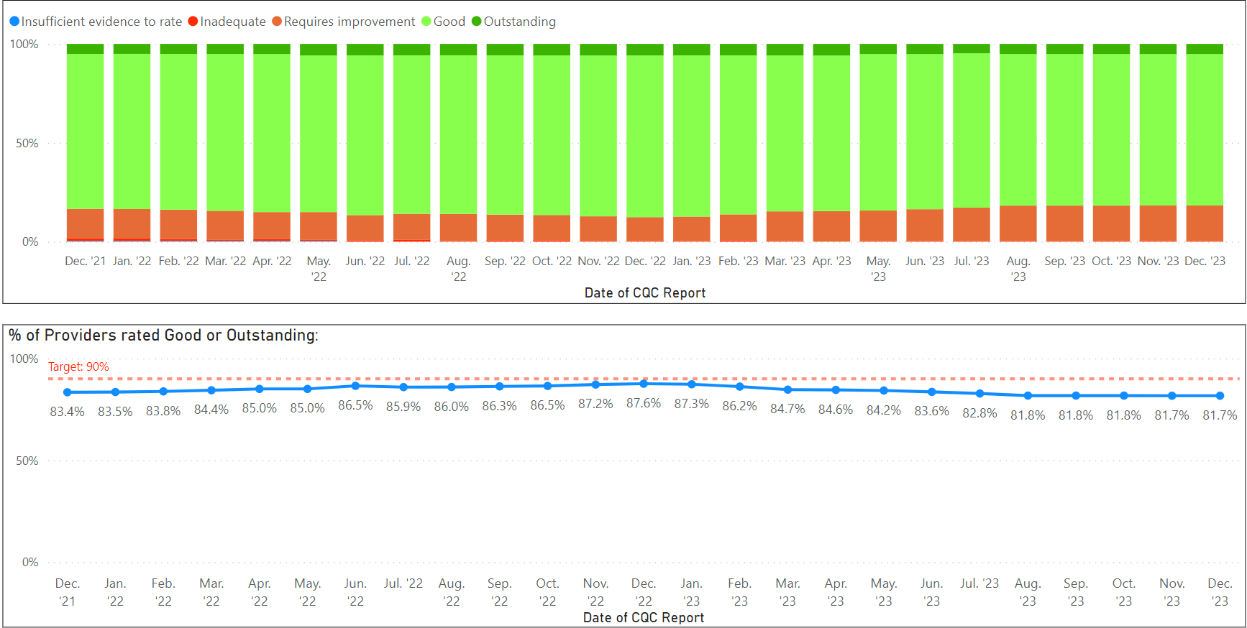  This is in part a consequence of the CQC currently only prioritising high risk provisions pending introduction of their new inspection framework from 6 December 2023 – the impact of this was discussed at the November 2023 Care Provider Commissioning & Quality Board and it was agreed Somerset Council would share recommendations with the CQC relating to provisions that we believe have improved in quality and would benefit from an inspection to ensure a fairer balanced approach to regulation.
3.20 | At the end of December 2023 placements were being restricted in 20 provider settings in Somerset by the Local Authority due to quality and/or safety concerns, or at request of provider:  - 5 settings are rated red – i.e. we are not currently placing;  - 15 settings are rated amber – i.e. we are placing but with restrictions.  Care market quality and sustainability continues to be closely monitored at a strategic level via the joint NHS/LA Commissioning and Quality Board (which met most recently in November 2023 and meets again later this month) and the Somerset System Quality Group (which met most recently in January 2024)
3.21 | Robust arrangements exist that help us monitor and support the quality and sustainability of local services, including our investment in PAMMS (Provider Assessment and Market Management Solutions) and our multi-agency Commissioning and Quality Board. Where necessary, we manage placements into provisions pending quality or safety improvements being progressed. We work closely with key stakeholders, including health colleagues and the Care Quality Commission, to share intelligence and support quality improvement and knowledge across the sector. We benefit from the insights of Healthwatch Somerset who share their ‘enter and view’ visit reports into local care settings with us as part of wider monitoring of people’s experience of local health and care services. 93% of feedback received during 2023 regarding the work of our Care Provider Quality and Contracts functions rated the overall service provided as ‘Good’ or ‘Excellent’, with 97% of this feedback stemming directly from local registered care providers. Our quality and contracts staff benefit from and receive regular training opportunities to support their knowledge and expertise in this area, with recent examples including Home Office ‘Right to Work’ training to support knowledge around immigration, and Contract Management training provided by the Government Commercial Function.
3.22 | Responding to business/provider failure: We also ensure effective multi-agency working aligned to our robust and well-tested business failure/closure policy - there are currently no home closures underway across the county but we supported several during 2023 where the provider has taken their own decision to rationalise their services.
4. | Implications and next steps
4.1 | - The Council needs to refresh the Market Position Statement, ensuring it reflects any local demand for care. This refreshed document will be developed in partnership with care providers. The Market Position Statement and the Market Sustainability plan will need to reflect the Council financial situation and forecast budgets for the next few years.  - Further work is in progress around the specialist care market (including services supporting adults with a learning disability, autism, or mental ill-health) to ensure projected need can be met. This will include the implementation of a new Dynamic Purchasing System (DPS) from 01/04/2024, detailed sustainability plans being developed, and work with housing as it is often the availability of housing, rather than care, that is problematic. As part of the introduction of the new DPS for specialist care we will be implementing the use of Care Cubed, a nationally recognised benchmarking tool, to benchmark the costs of all residential care and supported living packages as part of the process for agreeing each package commissioned using the DPS.  - The Council will continue to work in partnership with the Care Quality Commission, safeguarding, health and other partners to monitor and improve the quality of care offered in Somerset. Work is currently underway to determine the scope and mitigate the growing risk being seen nationally relating to the Home Office suspending or revoking UK Visa Sponsorship Licences held by independent care providers, given the impact this will have on capacity in the market and delivery of safe care.  - In March 2024, Somerset Council will welcome a Local Government Association Assurance Peer Challenge of its Adult Social Care service. The Peer Challenge will support our readiness for new CQC assessment of Local Authorities in relation to their discharge of their statutory duties under Part 1 of the Care Act 2014, and support an independent view of current strengths and areas for further development across our functions, including our commissioning and market shaping activity.
5 | Supporting papers
5.1 | Appendix 1 – DRAFT Market Position Statement, 2023-26

https://somersetcc.sharepoint.com/:b:/s/SCCPublic/EbzJGB-oQYhAmz03onho8WgBzCceTKFWxY14zTPPpyWxOg?e=yDNUyx
SCC - Public - Market Sustainability Plan 24.3.2023.pdf - All Documents (sharepoint.com)
Decision to award Contracts for Care and Support at Home in Somerset.pdf
Care Provider Quality Assurance Policy (somersetprovidernetwork.org.uk)
Regulated Care Provider: Business Failure Policy (somersetprovidernetwork.org.uk)

