Somerset Safeguarding Adults Board  Quality & Performance Subgroup  8 February 2024 | 
Overdue ASC Assessments and Reviews
Author: Angela King, Strategic Manager - Neighbourhoods
Organisation: Adult Social Care, Somerset Council
Contact Details: Angela.King@Somerset.gov.uk

- Summary
“In common with local authorities across the country, Somerset has high levels of overdue adult social care assessments and reviews”: There is concern form the Multiagency Performance and Quality subgroup that whilst triaging activity is undertaken to support risk management - issues of relevance to safeguarding may fail to be identified, escalated and/or prevented in a timely way or effective way linked to this demand and capacity challenge
This report aims to update the Safeguarding Adults Board subgroup with the latest position and data analysis relating to overdue assessment and reviews, performance in the last quarter and management actions being taken in relation to mitigating risk. Assurances relating to this area of activity is presented to the P&Q subgroup each quarter for oversight and monitoring by the multi-agency safeguarding Board.

- Background
There is a monthly operational Assurance Group, chaired by the Strategic Manager for Neighbourhoods, which scrutinises individual team performance across neighbourhood and community teams. It is attended by Strategic and Service managers to monitor individual team performance and prioritise team actions.
Validating and monitoring overdue work is a key focus for Advanced Practitioners in teams. Service managers and Advanced Practitioners meet regularly to track the most overdue work (365 + and 200-364 days). Targets are set and monitored by the Assurance group.
Each neighbourhood team holds a data day every 3 months to review waiting lists. This involves every team member being office based for the day and working in small groups they contact individuals on the waiting lists to check in with them and reprioritise the assessment request if necessary. These events ensure that people waiting an assessment are appropriately prioritised and any immediate action to meet their needs can be undertaken. It also removes individuals from the waiting list if their circumstances have changed.
In addition, Business Support teams now mirror the Neighbourhood teams in formation and each business support team undertakes data cleansing within Eclipse (the Adult Social Care case record system.)

- Overdue Assessments: Current performance
The total number of overdue assessments reduced from 1,730 at the end of October 2023 to 1,610 on 1st February 2024. January 2024 was used by all teams to undertake additional validation exercises closing duplicate work and completing finished worklists in Eclipse records.
Table 1 Overdue Assessments Summary 1st February 2024
Assessment Type | Number of Overdue Assessments | Variance on Last Quarter
Care Act Assessment | 899 | 865 (+34)
Carer's Assessment | 159 | 140 (+19)
Mental Capacity Assessment | 56 | 76 (-20)
Risk Assessment | 43 | 63 (-20)
Occupational Therapy Assessment | 453 | 586 (-133)

This is an improving picture on the last quarter with a 7% reduction overall in the number of overdue assessments across the board, although demand continues to increase pressure in the teams. It should also be noted that the overdue worklist is not a static list as overdue work is banded by the number of days overdue so the most overdue work (365+) figures can change on a daily basis.
Overdue Care Act Assessments
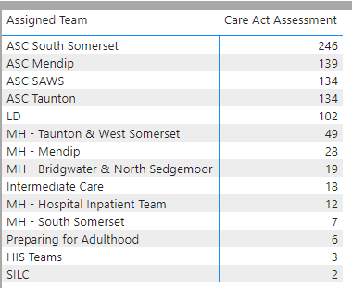
Overdue Care Act assessments have increased in the last quarter with South Somerset continuing to have the highest numbers of overdue work. This team remains significantly challenged with the highest number of locum staff and the highest number of vacancies across the county in the teams in this area. As an example the CLIC neighbourhood team has no permanent service manager, advanced practitioners, or social workers and is staffed entirely by locums in these roles. This leads to inconsistency and high turnover of staff. This is a recognised concern by the Adults Senior Management Team and a planned re-set of work in the South Somerset teams is being developed for February.
Overdue Carers Assessments
The number of Carers Assessments remains very low There are a greater number of combined Care Act and Carers assessments but separate carers assessments do not appear to being used in any consistent way across teams - this is due to be raised at the next practice Quality Board in March 2024 to look at improving consistency.

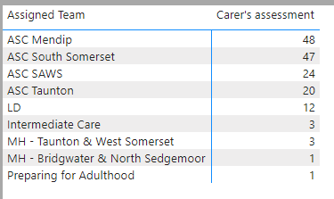
Overdue Mental Capacity Assessments
An audit was undertaken on 4th January 2024 of overdue Risk assessments and overdue Mental Capacity assessments. There were 36 overdue Mental Capacity assessments with 14 more than 90 days overdue, 10 of which were unassigned. When the audit was taken again on 1st February 2024 there were 56 overdue Mental Capacity assessments with 14 more than 90 days overdue and 10 unassigned to any worker. However it was noted that of the most overdue (365+ and 180 – 364 days) there were 3 people showing as 345, 577 and 605 days overdue respectively which do not appear on the January 2024 list at all - our Performance team have been requested to look into discrepency urgently.

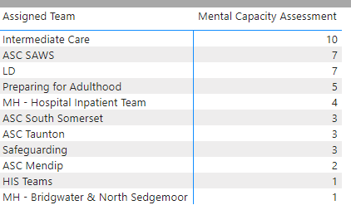
Overdue Risk Assessments
As above the January 2024 audit found that there were 42 overdue risk assessments on 4th January with 18 over 90 days and 4 unassigned. The February audit showed 43 risk assessments over due 14 over 90 days and 7 unassigned, however the same issue has occurred where the 2 oldest overdue risk assessments do not appear on the January list. The performance team is looking into this also.
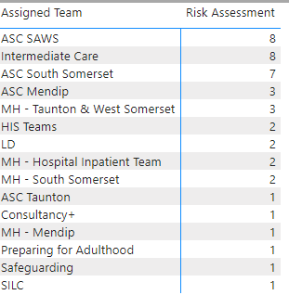
Overdue Occupational Therapy Assessments
Between September and December 2023, the OT service received 299 new referrals. Despite this high demand the number of overdue assessments are still decreasing each month. In the same period a total of 1,031 assessments have been included across all OT areas.
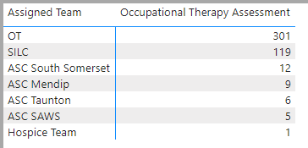
The opening of the new Somerset Independent Living Centre (SILC) in Yeovil has opened capacity for further improvement. Assessments which have been overdue for over 365 days have been substantially reduced and as at the end of January 2024 only 5 people are still waiting for their assessments, with 2 of these already allocated to a worker.
OT data Validation is ongoing as some of the data anomalies have still not been resolved. However, Moving and Handling assessments have now been separated into 2 forms which will improve data reporting.
Assessments Completed
All teams have increased the number of all assessments completed this quarter, compared to last quarter. This quarter has been the first full reporting period with the teams in their new neighbourhood formations. This may indicate that the smaller team focus is leading to increased productivity but this will continue to be monitored.
Table 2: Number of assessments completed
Teams | Assessments completed from August to October | Assessments completed from November to end of Jan
Mendip | 194 | 275
SAWS | 205 | 388
South Somerset | 142 | 243
Taunton | 151 | 220
PFA & LD | 38 | 65
MH East | 18 | 25
MH West | 18 | 20

Overdue Reviews
Overdue reviews remain high with an increase from 3,567 last quarter to 3,937 this quarter across all review types.
Table 4: Overdue Reviews as at 17/1/23:

Review Type | No. of Overdue Reviews Jan 24
Occupational Therapy Review | 75 (-73)
Occupational Therapy Moving & Handling Review | 298 (+96)
Review | 3,544 (+475)
Review of short term support | 9 (--)
Safeguarding review of protection plan | 11 (+2)
TOTAL | 3,937 (+500)

Occupational Therapy Review
The number of overdue OT reviews has reduced significantly to 74, however there has been a substantial increase in Moving and Handling reviews not being completed on time. This is due to historical use of an outside agency resulting in an unusually high number of people being marked for their annual review in January.

Out of Area reviews
Out of Area reviews are already undertaken in person where possible but following the request of the subgroup in November to consider increasing the frequency of face-to-face reviews and mindful of the “out of sight” guidance learning from SARs, a desktop review of all overdue out of area reviews has been undertaken in January.
The review has found a total 158 Out of County reviews were overdue. Exactly half of these (79) are in the neighbouring authorities of Devon, North Somerset, BANES, Bristol, and Dorset. Another 12 are in South-western Local authority areas.
The 50 most overdue reviews have been further scrutinised to consider when the last face to face review took place. 3 individuals have not had a face-to-face review since 2018 (they all had telephone reviews in 2021) and a total of 14 individuals have had no review since 2021. This group have been prioritised for a face-to-face review before the end of March 2024 and some mapping is still underway to group these reviews by location for expediency - for example there were 3 reviews undertaken in the last couple of weeks, in Glasgow by 1 worker.
The review has also given consideration if it appropriate for anyone in this most overdue cohort to consider a return to Somerset. For the majority of people this is not appropriate as they moved to be closer to family, however 5 individuals have been found to be in placements away from families locally in Somerset. Of these 3 are currently in prison and 2 could potentially return to Somerset to be nearer their families and communities.
Further Risk Mitigations being undertaken.
The next data days are due to be held in February 2024; this is part of the regular pattern of team events led by service managers which reviews risk in waiting lists in each team, using the risk assessment tool that was developed last year.
As part of the preparation for the Council’s LGA Assurance peer challenge to be held in early March 2024, our neighbourhood teams have been undertaking additional data validation exercises across staff caseloads, with individual staff members meeting with their line managers to review their caseloads; this is in addition to planned supervision where caseload is a standing item.
A quarter of overdue assessments are already allocated to a worker indicating work is in progress but not yet complete. This can be a significant mitigation factor for levels of unknown risk in overdue work but does have a negative impact on throughput and completion of work. Productivity of individual workers has been identified as a priority area for focus during the next quarter for managers, progress in this area will be reported in the next quarterly report to the Board.
Table 3: Overdue assessments already allocated across all teams
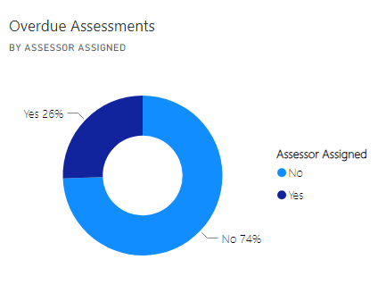
As outlined above, data validations have thrown up a number of anomalies in reporting that need further investigation, and this is currently impacting on accurate data reporting. This will hopefully be resolved for the next quarterly report.
The monthly Practice Quality Framework audit programme is continuing with all practitioners expected to undertake audits; outcomes are presented to the Adult Social Care Practice Quality Board to monitor learning and actions. The Practice Quality Board also disseminates learning from feedback and complaints which has included learning where people have had a crisis or deteriorated whilst waiting for assessments or reviews - these are a regular feature of team meetings in neighbourhood teams.
Recruitment remains a significant risk with all neighbourhood teams, Learning Disability and Preparing for Adulthood teams continuing to have many permanent vacancies and/ or locums. Since the introduction of the Council’s Establishment Recruitment Control Board in October 2023 as part of managing the Council’s financial emergency, Adult Social Care has had approval for the recruitment of 5 locum Social Work posts and several Advanced Practitioner posts. The recruitment of these is ongoing. There has been a recent shuffle around of management cover at service manager level to even up the numbers between East and West neighbourhood teams.
- Implications and next steps
During the last reporting Quarter (August to October 2023) all teams completed 2,208 Assessments, with an average length of completion of 36.26 days.
In this quarter there has been an increase in completed assessments but the average number of days to completion has increased to 43.71 days. Productivity will be a priority area of focus during the next quarter monitoring.
Out of County reviews remain a focussed piece of work following the desktop reviews by service managers with the focussed piece of work to complete the 50 most overdue reviews face to face by the end of March 2024.
- Background papers

