**Adult Social Care Financial Management and Decision Making**

**Date – November 2023**

**1. Introduction and Context**

Due to the seriousness of the financial situation across the council, Adult Social Care must implement a change in the way we authorise our funding decisions and ensure that we have the right decision making based on strength-based practice with clear consideration of our legal frameworks.

This guidance is being provided to ensure our workforce is supported to further promote our strength-based practice and to ensure that we have robust financial oversight of the Adult Social Care budget.

From the 20th November 2023 we will be implementing revised financial approval process across the operational service.

1. **Peer Forums - Strengths-Based conversations**

We want to achieve more Ideal Outcomes through supportive ​Strength-Based conversations within our Peer Forums, where we can offer solutions to promote more independent outcomes for individuals before plans are finalised​. Bringing the right minds together in the peer forums allows us to share experience and support each other on managing risk​ and with greater visibility of community resources will enable us to connect people to the community more, to promote independence. ​

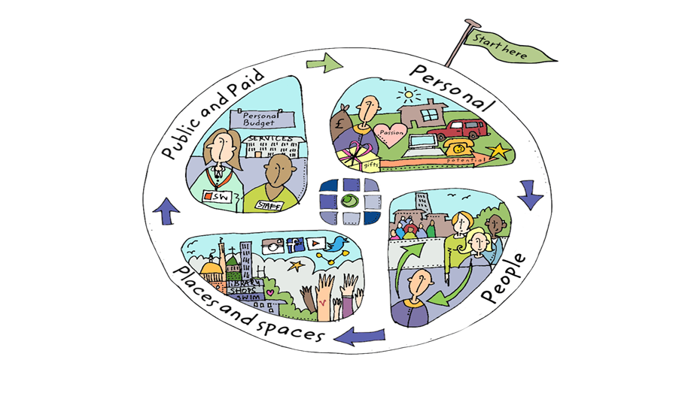

Peer Forums are a robust critical friend discussion with all members contributing, the forum should be multi-disciplinary with valued input from all professionals and community representatives. Peer Forums will take place across all Operational Service areas.

Peer Forums will critically discuss individual needs following Care Act assessment and or review and develop creative solutions for individuals requiring support from Adult Social Care. Peer Forums will discuss the individual strengths, needs, and ensure that all options have been explored including the use of equipment and tech enabled care for everyone before the support plan is completed and any request for paid services are authorised.

Peer Forums will be chaired by Service Managers and will discuss and consider the funding requests following robust strength-based conversations and completion of detailed costed support plans.

If the request is for over the agreed financial thresholds The Service Manager will add in their supporting recommendations to Peer Forum form on Eclipse and submit for Enhanced Peer Forum consideration. Both the Service Manager and Advanced Practitioner would have scrutinised the quality and evidence of the Care Act Assessment, Support Plan or Review to support the decision-making process.

|  |  |
| --- | --- |
| **Role** | **Responsibilities** |
| Member of staff presenting request | Books slot on Peer Forum calendar: workers name, Eclipse PER No and name of individual/ initials.  Ensure all relevant documentations are complete/ updated the Assessment, support plan and or review within Eclipse.  Complete the peer forum request form on Eclipse – only those completed via the Eclipse form will be considered. |
| Peer Forum members –  Expected members  Community Agent  ASCW  SW  OT  Health Colleagues | Peer Forum Members to come prepared to discuss individual cases and act as acritical friend.  When joining virtually Peer Forum members are expected to have their cameras on and engage with the discussion. Access relevant documents/Forms in Peer Forum on computers and contribute to discussion following the presenting case. This may include suggested actions relevant to the case to achieve the best outcome for individuals.  Assist with the quality audit of documentation, recording on Eclipse and assist with checking costings to support the Decision maker.  Ensure clear and accurate financial recording on financial spreadsheet.  Following robust peer forum discussion peer forum member updates the Eclipse Peer Forum form with clear recommendation from peer forum and agreed action. |
| Service Manager | Facilitates the Peer Forum, when undertaking virtual peer forums cameras must be switched on to ensure and encourage engagement across the forum.  Ensures documents summary and rationale for decision are completed, makes additional comments and recommendations, and ensures time limited packages are recorded.  Undergoes quality audit to ensure accurate documentation on Eclipse, ensures that an assessment or review has been Completed.  Provide feedback to individual presenter and peer forum members where appropriate and required.  Check service delivery is current.  Confirms next steps such as financial agreement, care order forum and documents this on the peer forum request form.  Record in or after Peer forum, costings on the financial spend on electronic excel sheet on SharePoint |
| Strategic Manager | Has overall accountability for spend against Service Area Budget. |

|  |  |
| --- | --- |
| **Peer Forum** | **Authorisation Level** |
| Packages of care in the community including supported living, day services up to a **total personal budget of £350** | Service Manager |
| Extra Care Housing up to a **total personal budget of £350** | Service Manager |
| Initial consideration for Residential Placement | Service Manager – Authorisation for any placement requests needs to be agreed at Enhanced Peer Forum |
| Respite at ASC Rates – **No more than 4 weeks per year** onto of existing Personal Budget. | Service Manager |

Requests for personal budgets above £350 per week and for any placement requests will need to come to Enhanced Peer Forum for discussion and decision making.

1. **Enhanced Peer Forums**

Enhanced Peer Forums will from the 20th November take place daily

* Monday – 1pm – 4.30pm
* Tuesday – 9am – 1pm
* Wednesday – 9am – 1pm
* Thursday – 9am – 1pm
* Friday 9am – 1pm

Enhanced Peer Forums will be chaired by either the Service Director for Adult Social Care Operations, the Strategic Manager for HIS and Intermediate Care or the Strategic Manager for Neighbourhoods. Enhanced Peer Forum members will also include colleagues from Commissioning, Finance, Sourcing Care the Principal Social Worker, Principal OT, Practice Development - Advanced Practitioners and Service Managers.

To ensure we bring the learning and discussions held at Enhanced Peer Forums back to the teams the expectation is that the Advanced Practitioners or the Service Managers attends with the individual worker when they present to Enhanced Peer Forum.

1. **Essential Documentation**

**Documents required to support all funding decision making**

|  |  |
| --- | --- |
| Peer Forum/Enhanced Peer Forum request via Eclipse | ALL requests to Peer Forums should be completed via the Peer Forum/Enhanced Peer Forum form in Eclipse. |
| Assessment/Support Plan/Review | Essential for agreement of personal budget – funding will not be agreed without this being completed on Eclipse. |
| Moving and Handling assessment – where required. | Will provide additional evidence to support agreement for personal budget |
| Occupational Therapy assessment –  Where required. | Will provide additional evidence to support agreement for personal budget |
| Health assessment – where required | Will provide additional evidence to support agreement for personal budget |
| Mental Capacity Assessment – where required | Will provide additional information |
| Best Interest Decision – where required | Will provide additional information |

1. **Audit Process**

To ensure we are adopting a strengths-based approach and we are robust in our financial decision making we will be undertaking peer forum audits. These will be facilitated by our Strategic Managers for Mental Health, Learning Disabilities and Neighbourhoods across all peer forum decisions on a weekly/monthly basis.

Our Strategic Managers will also be undertaking a review of the financial spend using the financial recording spreadsheets across all service areas on a weekly basis.

Peer Forum forms must be used so that we can produce reports via PowerBi on a regular basis and submit these to the Financial Oversight group. This will also enable us to monitor the spend across each service area.

1. **Care Act Guidance**

The Care Act 2014 requires local authorities to ‘consider the person’s own strengths and capabilities, and what support might be available from their wider support network or within the community to help’ in considering ‘what else other than the provision of care and support might assist the person in meeting the outcomes they want to achieve’.

Personalisation is about making sure there is an integrated, community-based approach for everyone and recognising people as individuals who have strengths and preferences and putting them at the centre of their own care and support.

Strengths-based practice is a collaborative process between the person supported by services and those supporting them, allowing them to work together to determine an outcome that draws on the person’s strengths and assets.

The Care Act 2014 requires an assessment of needs and then the setting of a personal budget to meet those needs. Where there is more than one potential option to enable the needs to be met, then the level of budget is set in accordance with the Care Act 2014 statutory guidance which says:

*10.27 In determining how to meet needs, the local authority may also take into reasonable consideration its own finances and budgetary position and must comply with its related public law duties. This includes the importance of ensuring that the funding available to the local authority is sufficient to meet the needs of the entire local population. The local authority may reasonably consider how to balance that requirement with the duty to meet the eligible needs of an individual in determining how an individual’s needs should be met (but not whether those needs are met). However, the local authority should not set arbitrary upper limits on the costs it is willing to pay to meet needs through certain routes – doing so would not deliver an approach that is person-centered or compatible with public law principles. The authority may take decisions on a case-by-case basis which weigh up the total costs of different potential options for meeting needs and include the cost as a relevant factor in deciding between suitable alternative options for meeting needs. This does not mean choosing the cheapest option; but the one which delivers the outcomes desired for the best value.*

The Council’s policy is summarised in information sheet B1 available on the public website which says:

*When we talk with you about your care and support needs we will also be able to roughly work out how much any care and support will cost.*

*This is called your* ***‘indicative budget’*** *and is based on our experience of how much it has cost people with similar needs. Knowing this will help start working out your care and support plan.”*