Safe administration of insulin

Safe Use of insulin Competency booklet
Trainee Name: _______________________

Date of training: ______________________
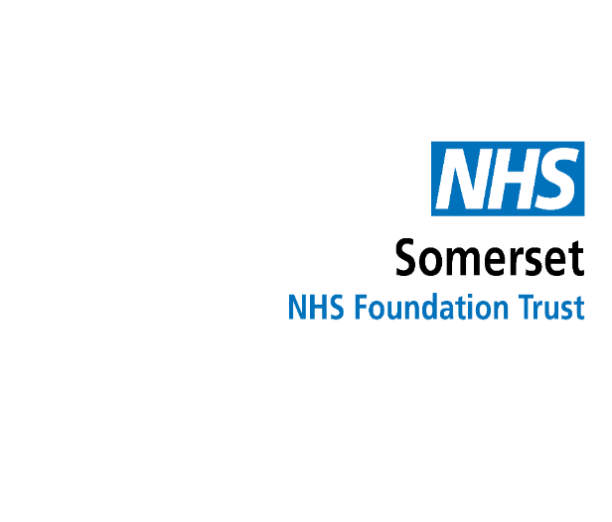
What is Diabetes?
What is diabetes?
Diabetes is a condition where the amount of glucose in the blood is too high because the body can't produce insulin, doesn't produce enough insulin or where the insulin doesn't work properly.
Insulin is a hormone produced by the pancreas that enables the body to use glucose in the blood for. It acts as the 'key' that 'unlocks' the body's cells to let glucose in, which is then converted to energy.
Glucose comes from the digestion of carbohydrates such as starchy foods, sugary foods and drinks, and natural sugars such as those in fruit and milk.

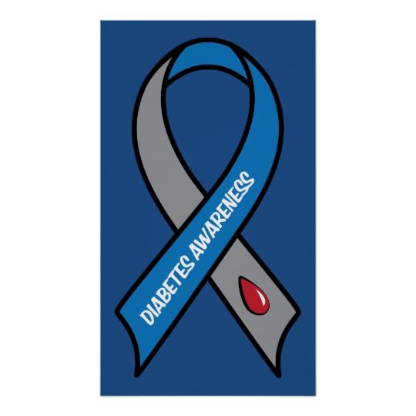

 | Type 1 Diabetes | Type 2 diabetes
Insulin | The body doesn’t produce any insulin as the insulin producing cells have been destroyed | The body can still produce some insulin, but not enough and/or the insulin doesn’t work properly (insulin resistance)
Onset | Symptoms can develop quickly | Symptoms tend to develop slowly
Age | Develops at any age, but usually before the age of 40 | Usually develops in people older than 40
Prevalence | Accounts for approximately 10% of all people with diabetes | Accounts for around 90% of all people with diabetes
Treatment | Treated with insulin (either by injection or insulin pump) alongside a healthy diet and regular physical activity | Treated with a healthy diet, regular physical activity and medication, which can be oral or injectable and can include insulin

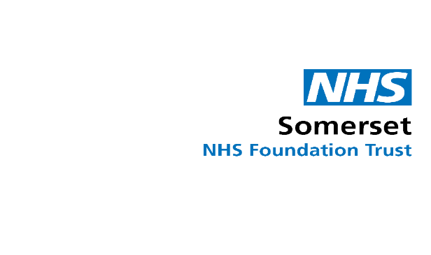
Risk Factors

Type 1 diabetes
No one is quite sure why insulin-producing cells in the pancreas of people with Type 1 diabetes are destroyed.
The most likely cause is due to an autoimmune response. This may be triggered by a viral or other infection.
Type 2 diabetes
There are certain risk factors that increase the chance of a person developing Type 2 diabetes.
Age
The risk of developing Type 2 diabetes increases with age.
This is particularly true for those over the age of 40. However, it can appear at an earlier age in people from a Black African, African Caribbean or South Asian background, generally 10 years earlier than people from White background.
Family history
A person is at increased risk of Type 2 diabetes if they have a close family member (parent or sibling) with diabetes.
Though the genetic aspects of Type 2 diabetes are complex, on average people with diabetes in the family are two to six times more likely to have diabetes than those without diabetes in the family.
Ethnicity
Research suggests that people from South Asian and Black communities are two to four times more likely to develop Type 2 diabetes than those from Caucasian backgrounds.
Weight
Not all people with diabetes are overweight, but being overweight or obese increases the risk of developing Type 2 diabetes. It is the most potent risk factor for Type 2 diabetes.
Waist circumference
An increased waist circumference is associated with an increased risk of Type 2 diabetes. Risk is increased in:
Women who have a waist measurement over 80cm (31.5 inches)
Men who have a waist measurement over 94cm (37 inches) or over 90cm (35 inches) for South Asian men
High blood pressure / history of heart attack or stroke
If a person has high blood pressure, a previous heart attack, or a stroke, then they are at increased risk of Type 2 diabetes.

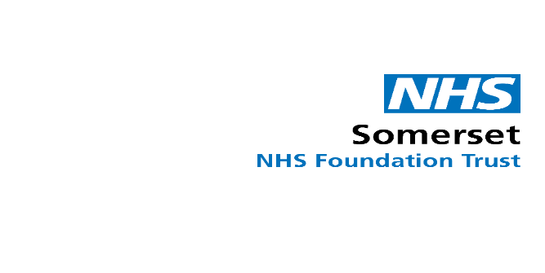
The common symptoms of diabetes are:

Feeling tired during the day, particularly after meals (fatigue)

Often feeling hungry, particularly if you feel hungry shortly after eating (polyphagia)

Urinating more often than normal, particular needing to do so during the night (polyuria)

Feeling abnormally thirsty (polydipsia)

Blurred vision

Itching of the skin, particularly itchiness around the genitals (genital itchiness)

Slow healing of cuts or wounds

Having regular yeast infections (thrush)

Having a skin disorder such as psoriasis or acanthosis nigricans

Sudden weight loss or loss of muscle mass.

Prior to checking blood glucose and administering insulin the risk assessment must be checked and consent obtained or the principles of best interest and mental capacity followed

Symptoms
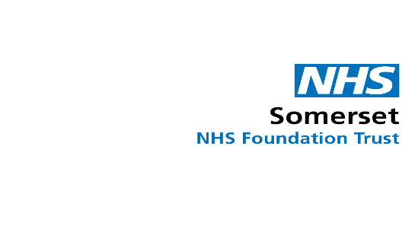
Testing your client’s blood glucose levels (CBG)
You’ll need these things to do the blood glucose test:
- a blood testing monitor called a glucometer
- a finger prick lancing device
- test strips
- a yellow sharps bin, so you can throw the needles away safely
- a diary to record blood glucose levels
- liquid control solution
Wash your and your client’s hands with soap and warm water. Don’t use wet wipes as the glycerine in them can affect the test result. Make sure your client’s hands are warm so it is easier to obtain a blood sample.
Check the test strips are in date. Take a test strip and slot it into the monitor. This will turn it on.
Remove the cap from the safety lancets. This usually twists off. Choose which finger to prick but avoid your client’s thumb or index finger. Do not prick the fleshy pad of their fingers as this is where the nerve endings are, or too close to a nail. Place the device firmly against the side of your client’s finger and press the clicker. Vary the site that you use for testing.
Gently massage down the finger to allow a drop of blood to appear. Take the monitor with the test strip and hold it against the drop of blood. When there is enough blood on the test strip the glucometer will start counting down on the screen.
Before looking at the reading, check your client’s finger. Use a tissue to stop bleeding. By this time, the meter will probably show the result.
You can use the same tissue to remove the test strip. Discard along with the safety lancet into the sharps bin.
The optimal range for blood glucose is between 4 and 7 mmol/L some people may run higher. Please ensure you have discussed the client’s glucose target with their Diabetic Nurse or GP to determine what is an acceptable range for them. Record their results in their diary. If the blood glucose is stable and within your client’s personal target range, then no action is needed. If their glucose levels are regularly outside of range, or they experience hypoglycaemia or symptoms of hyperglycaemia then you should contact their GP surgery for assistance.
It is important for people with diabetes to have accurate information about their blood sugar levels. If the monitor or test strips are faulty you will receive inaccurate blood glucose readings.
A control solution is used to determine the accuracy of the test strip and monitor. The control solution contains glucose, when it’s placed on a test strip, it will react to it and the monitor will take a reading.
How to use the control solution - Place a test strip in the monitor, place a drop of control solution against the test strip as you would apply a drop of blood, this will then give you a reading which should fall between a specified range shown on the test strip pot. If it is outside this range then there is a problem with your monitor or test strips, further investigation is needed to determine the source of the problem.
You should carry out this test monthly as recommended by the manufacturer, every time you open a new box of strips, if the monitor is dropped or if you get unusually high or low readings.
Note a libra device result is 5 minutes behind a CBG. If showing very high or low take CBG

Hypoglycaemia

What is a Hypo
Glucose is a sugar carried in the bloodstream that the body uses for energy. If a person
has diabetes and takes certain treatment, their blood glucose levels can sometimes become too low. This is called hypoglycaemia (or a “hypo”) and occurs when their blood glucose level drops below 4 mmol/L.
k SYMPTOMS

Symptoms
Early signs and symptoms of a hypo include:
Sweating heavily,
Feeling anxious,
Becoming pale
Trembling and shaking.
Tingling of the lips,
Palpitations,
Hunger
anxious
Symptoms may vary from person to person, but your client may feel “different” very quickly. Please note that some people never have symptoms of hypoglycaemia.
If you miss these early signs, the symptoms may get worse and include:
Slurring their words.
Behaving oddly
Being unusually aggressive or tearful.
Having difficulty in concentrating.

If you do not treat your client’s hypo at this stage, they may become unconscious.
Treatment2k HOW TO TREAT HYPOS
Treatment
As soon as you notice the symptoms of a hypo or if a blood glucose test shows
that your client’s level is too low (4 mmol/L or less), you should treat it immediately with
something that will raise their blood glucose quickly. Suitable quick-acting glucose
treatments to provide 15g to 20g carbohydrate are:
200ml (a small carton) of smooth
orange juice
60 ml Glucojuice or Lift 5 glucotabs
6 dextrose tablets
5 jelly babies

Be aware that some soft fizzy drinks may now have a lower sugar content.
If your client does not feel better after 10 minutes (or their blood glucose level is still less than 4 mmol/L) repeat the treatment above once more. Seek emergency medical attention if hypoglycaemia persists or if the client becomes unconscious.
Once the glucose level is above 4 mmol/l give some starchy food, like 2 plain biscuits or a small banana or their next meal if it is due.

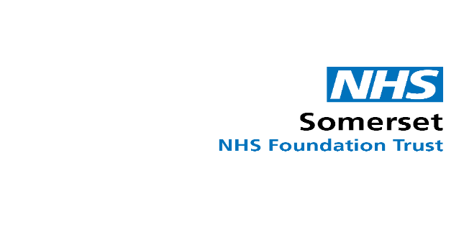
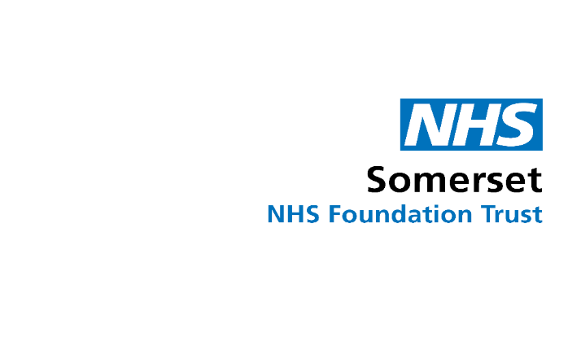
Storing your insulin
Rapid-acting insulin:
This type should be taken shortly before meals or soon after when necessary. It peaks within 30 to 90 minutes, and its effects last for three to five hours. Types of insulins include NovoRapid® and Humalog®

Short-acting insulin:
This type should be taken 30 minutes before food. It peaks in two to four hours, and its effects can last for five to eight hours. Types of insulins include Humulin S and Actrapid

Intermediate-acting insulin:
This type of insulin should be taken as determined by your client’s healthcare team. These insulins have variable action and work for up to around 18 hours. Types of insulin include Humulin I and Insulatard®

Long-acting insulin:
This type of insulin should be taken as determined by your healthcare team. These insulins can work for between 18 and 36 hours. Types of insulin include Levemir® & Lantus®

Pre-mixed:
This is a combination of two different types of insulin: one that controls blood glucose at meals and another that controls blood glucose between meals. These types of insulin include NovoMix® 30 and Humalog Mix 25.

Keep any insulin you are not using in the salad drawer of the fridge. Do not put it in the freezer compartment as it will destroy the insulin. The insulin pen you are using can be left out of the fridge for up to one month, please keep it out of direct sunlight.
Insulin needs to be kept at temperatures lower than 25°C (77°F). The ideal storage temperature is 2 to 6°C (36 to 43°F). Room temperatures can be below 25°C, but they can be higher if the heating is on or it is summer, if so, keep your insulin in the fridge.

Types of Insulin
To inject insulin safely you will need:
An insulin pen – this can be one that is pre-filled with insulin in which you throw away after it is empty, or an insulin pen you can reuse by changing the insulin cartridge yourself.
A needle – this is small and thin, it is designed to inject the insulin into the fatty area under the skin, not into a muscle or vein. A new needle is required for each injection.
A sharps bin – this is where you will safely throw away the needle.
Everything you need is available for free on prescription.
How to inject insulin
Wash and dry your hands.
Obtain consent.
Choose where you are going to inject – you are looking for a soft fatty area, so the main injection sites are your client’s stomach under their belly button from hip to hip, the sides of their thighs, hips and bottom. It is important you vary the injection site and choose a different area each time – at least 1cm or half an inch from where last injected. If not, lumps can appear called lipohypertrophy that will stop your client’s body absorbing and using the insulin properly.
Attach the needle to the pen by removing the paper from the bottom of the needle, screw this onto the insulin pen. Once secure remove the outer and inner caps (if using a safety needle there is only one cap to remove)
*Have you got the correct client ? The correct insulin? The correct dose? The correct time?The correct device, correct way of administration. Is the blood glucose level 4mmol/L or above?*
Dial up two units of insulin. Point your pen upwards and press the plunger until insulin appears from the top of the needle. This is known as an air shot and should be performed before every injection to ensure the pen and needle are working.
Dial your client’s dose and make sure the area you are injecting is clean and dry. Always double check the insulin dose before administering.
Insert the needle directly into the skin at a 90° angle. You might want to gently pinch the skin before injecting if there is no fatty tissue available. Press the plunger until the dial goes back to 0.
Count to 10 slowly to give the insulin time to disperse, before removing the pen.
Unscrew the needle using the outer needle cap, then place it into the sharps bin. Sharps bins should be locked shut once 2/3 full and the local district council should be contacted for collection and replacement with a new one.
Safe administration of insulin
Competency assessment | Yes | No | Trainee signature/date | Assessor signature/date | Comments
Explain the symptoms of diabetes
Identify the difference between type 1 & type 2 diabetes
Identify the risk factors for developing diabetes
Know how to check a blood glucose level and what the results mean
Know the symptoms of, and how to safely treat a hypoglycaemic episode
Know the symptoms of Hyperglycaemia and DKA and what action to take
Describe the different types of insulin and how each one works
Identify how to safely store insulin

How to safely administer insulin

How to safely dispose of sharps

How to record blood glucose results
Know when to refer to the Diabetic Nurse or GP
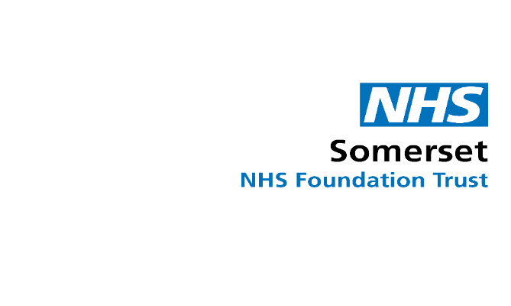

Practical assessment
SKILL | Date trained | Date assessed | Assessed by | Comments
Perform QC test Check and record blood glucose levels
as described above

Check and record blood glucose levels as described above

Check and record blood glucose levels as described above

Check and record blood glucose levels as described above

Check and record blood glucose levels as described above

Administer insulin and safe disposal of sharps as described above
Administer insulin and safe disposal of sharps as described above
Administer insulin and safe disposal of sharps as described above
Administer insulin and safe disposal of sharps as described above
Administer insulin and safe disposal of sharps as described above

Signed off by: _______________________________
Date signed off: ______________________________

Congratulations on completing your training. Once you have completed your competencies and had them signed off by the District Nurse you will be able to carry out the delegated task of administering insulin as per the prescription on the Medicine Administration Chart.
Remember the delegation is voluntary so if at any time you feel unable to administer insulin, please discuss this with your manager.
This is a delegated task and as such the District Nurses remain accountable for the delegation but you are accountable for your actions in administration.
You can administer insulin to other clients who are having prescribed insulin as long as there has been a risk assessment and care plan completed for them and you have been pre-allocated to do this on any given day.
You will need to repeat the online training yearly, the competency for hypoglycaemia 3 monthly, the competency for administration of insulin 6 monthly and the competency for the blood glucose monitoring yearly.
If you are involved in an incident, then the District Nurse will determine any action required to be taken.
If you have a gap in practice of more than 3 months, you must repeat the training and competencies before you administer insulin to any client.
A District Nurse will liaise with your care home or domiciliary care manager weekly to ensure that the administration is safe. If you have any concerns regarding the delegation or the health condition of your client, then please contact your manager or the District Nurse team.
Each client should have a ‘hypo bag’ containing the trust protocol on how to treat hypoglycaemia and glucose drinks and sweets that can be given if they have a hypo. This will need to be restocked when used.
There is a free RCN accredited course on Diabetes in Healthcare available at https://www.diabetesinhealthcare.co.uk

Note:-
Competency must be assessed on a client- not in simulation.
It can be assessed up to 5 times but can be signed off after 2 assessments if the carer is competent.
If there are two clients that a carer is administering insulin to the competency does not need to be reassessed on each client

