infoccu@somerset.gov.uk
Have you made plans?

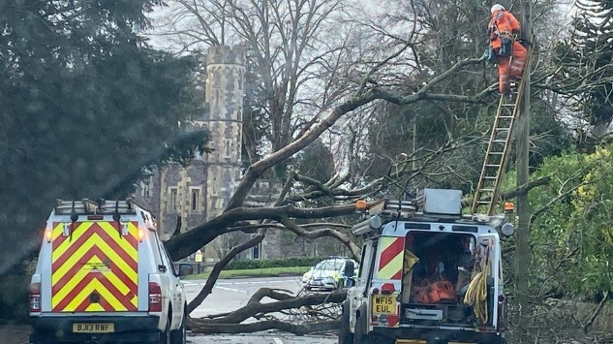
During Storm Eunice in 2021, 400,000 properties lost power in the UK. An estimated 35,000 in the Southwest.
There are around 2005 care facilities across Somerset- Have you considered what you will do if your facility was affected by foreseen or unforeseen disruptions?

Business Continuity Plans can be made quickly and simply. It is about identifying your critical functions and maintaining resilience during disruptions when they happen. It is a temporary solution while damage is being repaired.

You are probably already doing this in some form daily!
Continuity in 3 Easy P’s-
When making your plans consider the effects of a disruption and not the cause
A storm is a cause, the effect might be:

People- Staff not getting to work- how do you fill those spaces and workloads?
Power- If your business requires power to maintain essential functions consider how you will cope without it
Premises- In the event of the loss of your place of work you might plan for a backup location to relocate to

There are two more P’s to consider! Process- IT, telephones and ways to communicate if they are lost. And Provider- Suppliers of necessary logistics to run your business

The Civil Contingencies Unit at Somerset County Council offers guidance on Business Continuity Management (BCM) and mitigating disruptions using real examples.
Our aim is to develop contingency plans and arrangements to help in a disruption

Take ownership of your business by mitigating disruption.

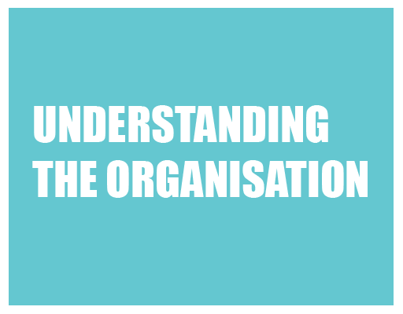
Identify your essential activities that need to be continued during an incident

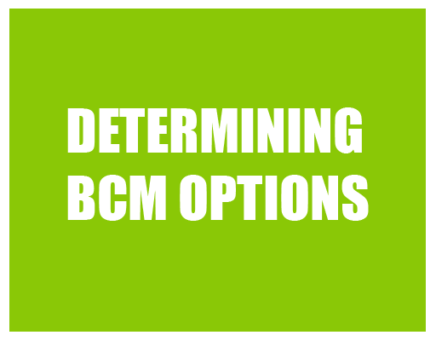
What do you do?/ How you do it?/ What resources do you need to do it?

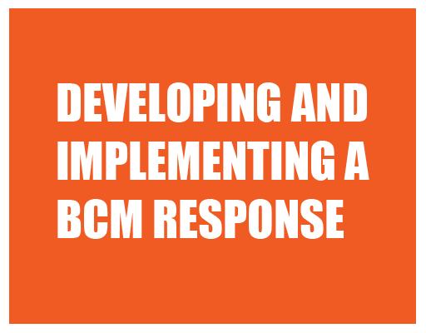

Identify organisational risks or threats and actions that will mitigate them
(deal with it/outsource it/leave it)

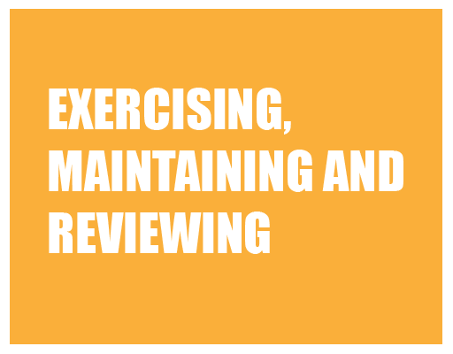
Plans should be validated and developed during events that threaten the continuance of normal day-to-day business

Plans should be reviewed and tested, from a simple test of call out arrangements to a desktop exercise measuring the planned response

Make plans now – This helps reduce the likelihood of a disruptive event occurring and ensures the delivery of essential activities that are maintained to an acceptable level during disruption. It will also help create a culture of resilience in your place of work.
Without a plan there would be no pre-planned strategies to help when you need them most.

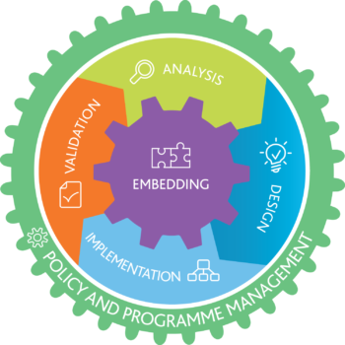
What would you do if. . . . .?

Useful links- There is a plethora of information on Business Continuity Management.
We believe in keeping things simple, here’s 3 to start
What is Business Continuity? - YouTube
Preparing for a power cut - YouTube
Good Practice Guidelines

We aim to create a culture of resilience over compliance

