Trainee Nursing Associate Factsheet
Entry requirements to programme:
- Maths (level 4/C or above) or Functional Skills Level 2
- English (level 4/C or above) or Functional Skills Level 2
- Level 3 qualification or equivalent academic level e.g. A Levels/QCF
Programme detail:
- 2 Year Programme
- Works as a trainee Nursing Associate (tNA) with Team (base employment area)
- 20% Supernumerary (Academic)
- 460 supernumerary hours over the 2-years (Placement away from base area)
Base placement hours
Year 1 Year 2
9 Academic Modules throughout the 2 year programme
1 study day a week to attend Uni
REGISTERED
NURSING
ASSOCIATE
NMC registration
460 placement hours arranged by the placement team

20% off the job, new learning that needs to be evidenced.

The 460 supernumerary placement hours away from base will be made up of a combination of either 1 week or 2 week placement at a time. The study day at University will be a set day of the week throughout the 2 years.
Support
CPEP Nursing Associate Practice Facilitator can help with the following:
- Recruitment process – shortlisting of candidates, interviewing process
- Pastoral support
- Advice for Practice assessors/Practice supervisors
- Managers support
- Provide a link between all parties –education provider, work and placement areas.
- Placement planning
Link of the standards from the NMC website for TNAs
Standards for pre-registration nursing associate programmes - The Nursing and Midwifery Council (nmc.org.uk)
Contacts:

For Social Care enquiries: Rebecca Everett Rebecca.everett@ydh.nhs.uk

Nursing Associate Factsheet
Qualifications
- Nursing Associates have gained a Foundation Degree.
- Registered members of the Nursing and Midwifery Council.
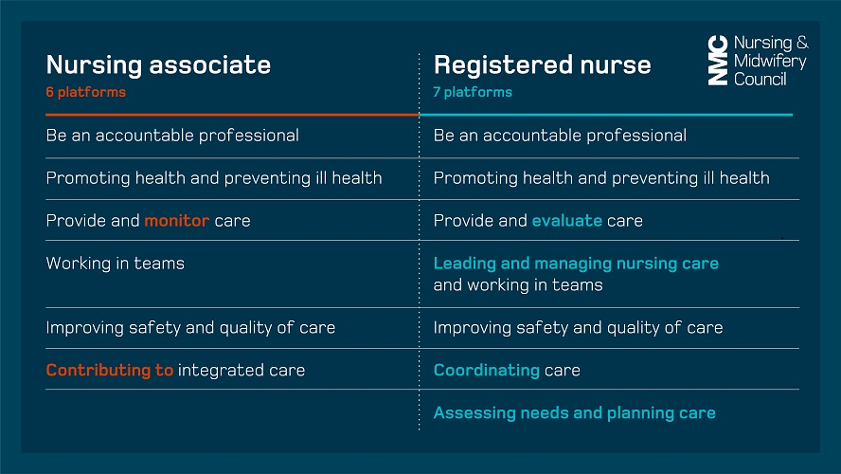
Below are the NMC pillars defining the differentiation between Registered Nursing Associates and Registered Nurses.

Further opportunities to progress their career
Registered Nurse Degree Apprenticeship (RNDA) RPL route – often known as the ‘top-up’. 2 year apprenticeship route.
Extended roles – examples of this include roles within education, Clinical Nurse specialist teams and theatre departments.
Celebrate being a Nursing Associate
Support
CPEP Nursing Associate Practice Facilitator can help with the following:
- Pastoral support
- Managers support
- Guidance for newly qualified NA’s
Link to the standards from the NMC website for Nursing Associate’s
Standards of proficiency for registered nursing associates - The Nursing and Midwifery Council (nmc.org.uk)
Contacts:

For Social Care enquiries: Rebecca Everett Rebecca.everett@ydh.nhs.uk

