Personal Pressure Ulcer Prevention Plan
CHECK YOUR PRESSURE AREAS REGULARLY
YOU CAN USE A MIRROR OR ASK A CARER OR RELATIVE TO HELP YOU
POTENTIAL PRESSURE POINTS DEPEND ON YOUR POSITION
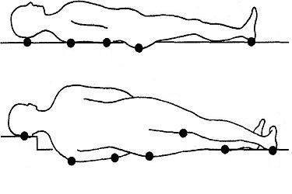
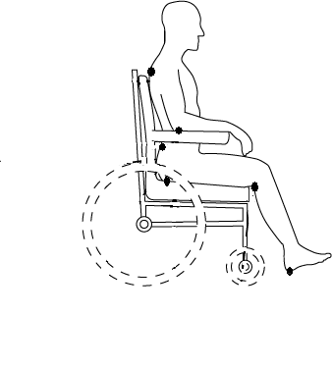

Your specific areas of skin at risk are ............................................................. (as circled above)
It is recommended that you should:
Move your position at least every .................. hours and inspect your skin ……………… (add frequency.
If you are concerned contact your health professional on ........................................................
REMEMBER TO GET HELP PROMPTLY IF YOU NOTICE A RED AREA THAT DOES NOT FADE
Your signature .......................................................... (to confirm your plan has discussed with you)
Health professional’s signature .............................................. Date..................................................Print Name………………………………….. Designation……………………………………………………

