Finger Tip Test
The skin needs a blood supply to stay healthy. Capillaries running through the skin supply blood and nutrients to the cells and removes waste products.
When soft tissues are squashed between bone & a surface (i.e. bed or chair) these tiny capillaries are squeezed and blood cannot flow properly.
A normal response is to change position and relieve the pressure. When this happens the skin turns red. (The redness is caused by a temporary increased blood supply to area to remove waste products, & bring oxygen and nutrients)
This is normal and when gently pressed the reddened area will blanch white (as the blood is pushed out of the capillaries) then go red again (as the capillaries refill).
However, if the pressure remains unrelieved the tissue becomes damaged. This time the reddened area does not blanch when gently pressed.

Gently press the reddened area of skin.  If healthy the red area will blanch white then turn red again normally within 3 seconds.  Blanching redness = normal reaction | 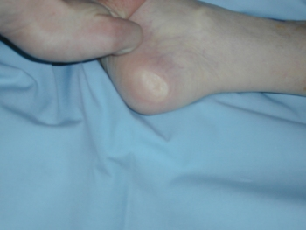  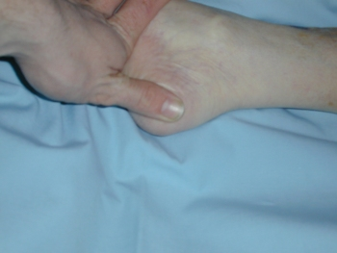
If the red area does not blanch white then  Non blanching erythema (redness) = Category 1 pressure ulcer  Take immediate action to relieve pressure to prevent further damage | 